CMPS 350 Project Phase 2 – Report
Education Platform
(10% of the course grade)
The report must be submitted in Word format only
Group Members | Nagham Alajmi 202002078  Lama Aldosari 202103338  Shaikha AlAli 202001976  Student4 full name (StudentId)  Emails: la2103338@qu.edu.qa  Na2002078@qu.edu.qa  Sa2001976@qu.edu.qa  student3@student.qu.edu.qa;
GitHub link | Give a public link to you code (It is not acceptable to send codes by email)

Grades :
The student fills only the “Implementation Percentage”: Please specify either: Working (completed x%), Not Working (completed x%) or Not done.
Criteria | % | Functionality* | Quality of the implementation | Grade
Design and implement the Data Model. | 10 | Working 100%
Init DB: populate the database with the data from the json files in seed.js | 5 | Working 100%
Server actions, APIs and Repository Implementation to read/write data from the database | 25 | Working 100%
Statistics use-case with NextJS | 40 | Working 100%
Documentation  - Data Model diagram.  - UI Design with screenshots and description.  - Database queries.  - Conducted tests and evidence.  - Contribution of each team member [-10pts if not done] | 20 | Completed 100%
Total | 100
Copying and/or plagiarism or not being able to explain or answer questions about the implementation. | -100

Important remark: In case of copying and/or plagiarism or not being able to explain or answer questions about the implementation, you lose the whole grade.
* Criteria for grading the functionality:
- The functionality is working: you get 70% of the assigned grade.
- The functionality is not working: you lose 40% of assigned grade.
- The functionality is not implemented: you get 0.
- The remaining grade in all cases from above is assigned to the quality of the implementation,
- The grades are distributed on the various use cases, when the design/implementation is partial, you get only the grades of designed/implemented use cases.

Code quality criteria, include:
- Use of meaningful identifiers for variables and functions (e.g. using JavaScript naming conventions)
- Pages are responsive
- Clean code: simple and concise code, no redundancy
- Clean implementation without unnecessary files/code
- Use of comments where necessary
- Proper code formatting and indentation.

You lose marks for code duplication, poor/inefficient coding practices, poor naming of identifiers, unclean/untidy submission, and unnecessary complex/poor user interface design.

Important Remark:
[Grades: 100-85]: Will be given only to fully functional application with all the quality criteria cited above met and the project has excellent design for the various functionalities. The report is professional.
[Grades: 85-80]: Will be given only to functional application with most of all the quality criteria cited above met and the project has good design for the various functionalities. The report is professional.
[Grades: 80-75]: 80% of the application functionalities are functional. The project respects partially the quality criteria. The report is professional but misses some information.
The grades are not negotiable. We expect that only a small portion (around 15%) of the class will be able to meet the criteria for the grades [100-85]. You should work hard to and demonstrate the merits of your application to earn those grades.+

Description of your proposed platform
Our Project focused on building a student management system that uses Next.js, React, Prisma ORM, and SQLite as the database. The project enables admins and users to perform many operations like managing, updating, adding, deleting, tracking, and viewing records. In this phase we utilized both web APIs and server actions to handle data operations. Moreover, we developed a fully functioning statistics dashboard that displays student information and more. The data has been seeded from JSON files into a database using Prisma.

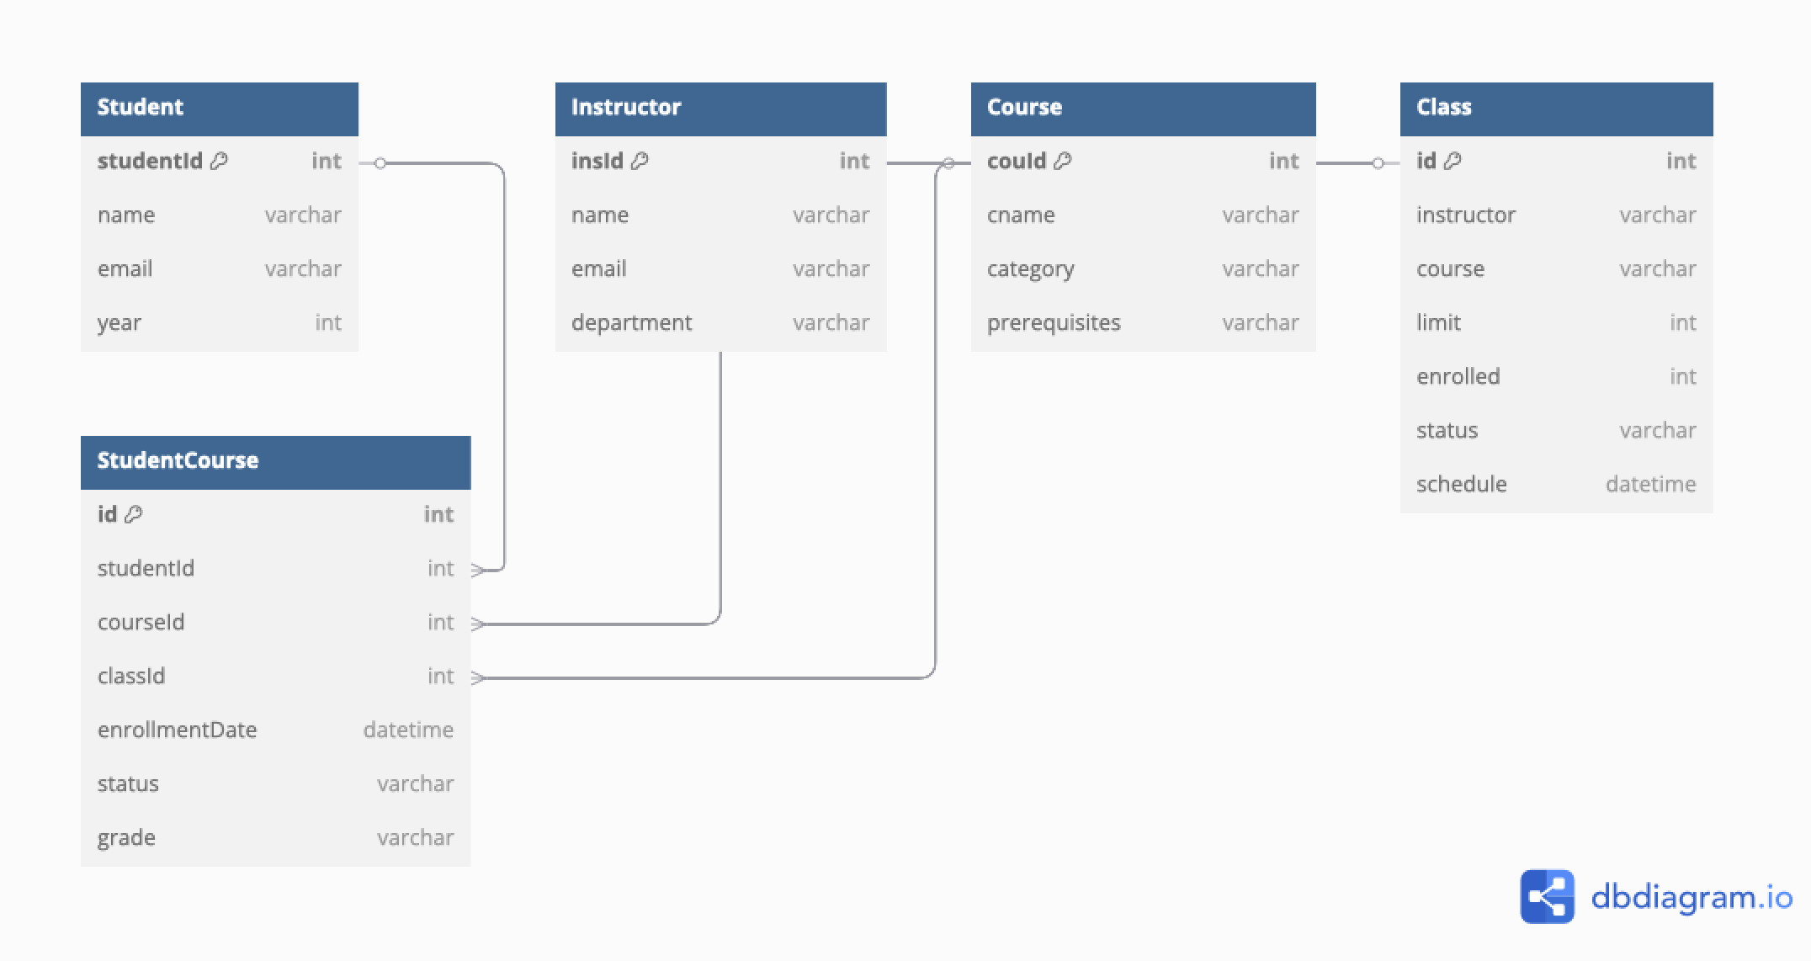
Data Model

Web API, Server Actions and repository
Repo (repo/studentManagement.js)
Operations:
- getAllStudents()
- getAllInstructors()
- getAllCourses()
- getAllClasses()
- getStudent(id)
- getInstructor(id)
- getCourse(id)
- getClass(id)
- createStudent(studentData)
- createInstructor(instructorData)
- createCourse(courseData)
- createClass(classData)
- getStudentsByYear(year)
- updateStudent(id, updatedData)
- updateInstructor(id, updatedData)
- updateCourse(id, updatedData)
- updateClass(id, updatedData)
- deleteStudent(id)
- deleteInstructor(id)
- getOpenClasses()
- getCourseByCat(category)
- getStudentsByCourse(courseName)
- getStudentsCountByYear()
- getStudentsCountByCategory()
- getStudentsCountByCourse()
- getTopThreeCourses()
- getFailureRateByCourse()
- getFailureRateByCategory()
- getAverageGradeByCourse()
- getEnrollmentTrendByCategory()
- getTopInstructorsByClassCount()
- getCourseCompletionRateByYear()
- getDepartmentPerformance()
- getClassUtilization()

Server Action
getAllStudents()
getStudentById(id)
createNewStudent(studentData)
updateStudentInfo(id, updatedData)
removeStudent(id)
getStudentsByYear(year)
getAllCourses()
getCourseById(id)
createNewCourse(courseData)
updateCourseInfo(id, updatedData)
removeCourse(id)
getCoursesByCategory(category)
getAllInstructors()
getInstructorById(id)
createNewInstructor(instructorData)
updateInstructorInfo(id, updatedData)
removeInstructor(id)
getAllClasses()
createNewClass(classData)
updateClassInfo(id, updatedData)
removeClass(id)
getOpenClasses()
getStudentsByCourse(courseName)
getStudentsCountByYear()
getStudentsCountByCategory()
getStudentsCountByCourse()
getTopThreeCourses()
getFailureRateByCourse()
getFailureRateByCategory()
getAverageGradeByCourse()
getEnrollmentTrendByCategory()
getTopInstructorsByClassCount()
getCourseCompletionRateByYear()
getDepartmentPerformance()
getClassUtilization()
export const authenticateUser
export const getCourses
export const logoutUser

Web API
- GET app/api/class – gets all classes
- POST app/api/class – creates classes
- GET app/api/class/[id] – gets a class
- PUT app/api/class/[id] – updates a class
- GET app/api/course – get all courses
- POST app/api/course – creates course
- GET app/api/course/[category] – gets course by category
- GET app/api/course/[id] – gets a course
- PUT app/api/course/[id] – updates a course
- GET app/api/instructor – gets all instructors
- POST app/api/instructor – creates instructor
- GET app/api/instructor/[id] – get a instructor
- PUT app/api/instructor/[id] – update a instructor
- DELETE app/api/instructor/[id] – delete a instructor
- GET app/api/open – gets all open classes
- GET app/api/student – gets all students
- POST app/api/student – creates student
- GET app/api/student/[id] – get a student
- PUT app/api/student/[id] – update student
- DELETE app/api/student/[id] – delete student
- GET app/api/student/year/[year] – get students by year

Implemented statistics use case

User Interface:

In this phase, we developed an interactive statistics dashboard exclusively using Next.JS, React, and Prisma. The dashboard visualizes key student, course, and performance data using live queries from the database and is accessible from the home page.
The dashboard is organized into four tabs: Overview, Students, Courses, and Performance. Each tab presents relevant visualizations (bar charts, pie charts, tables, …) for key statistics such as enrollment, course category distribution, failure rates, GPA, and class utilization.

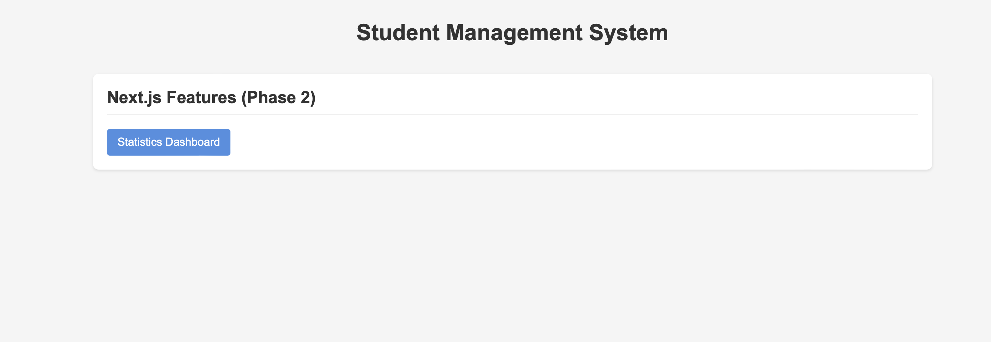

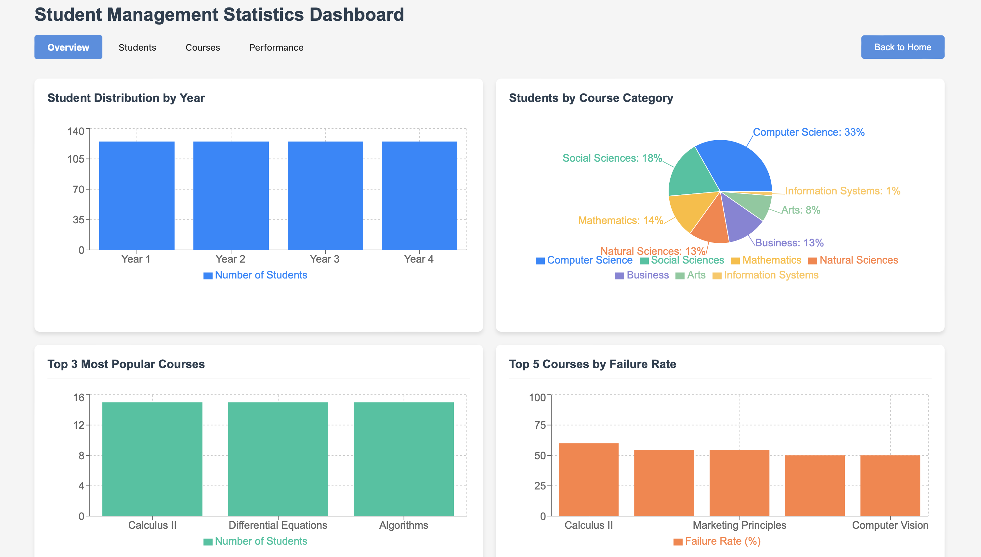

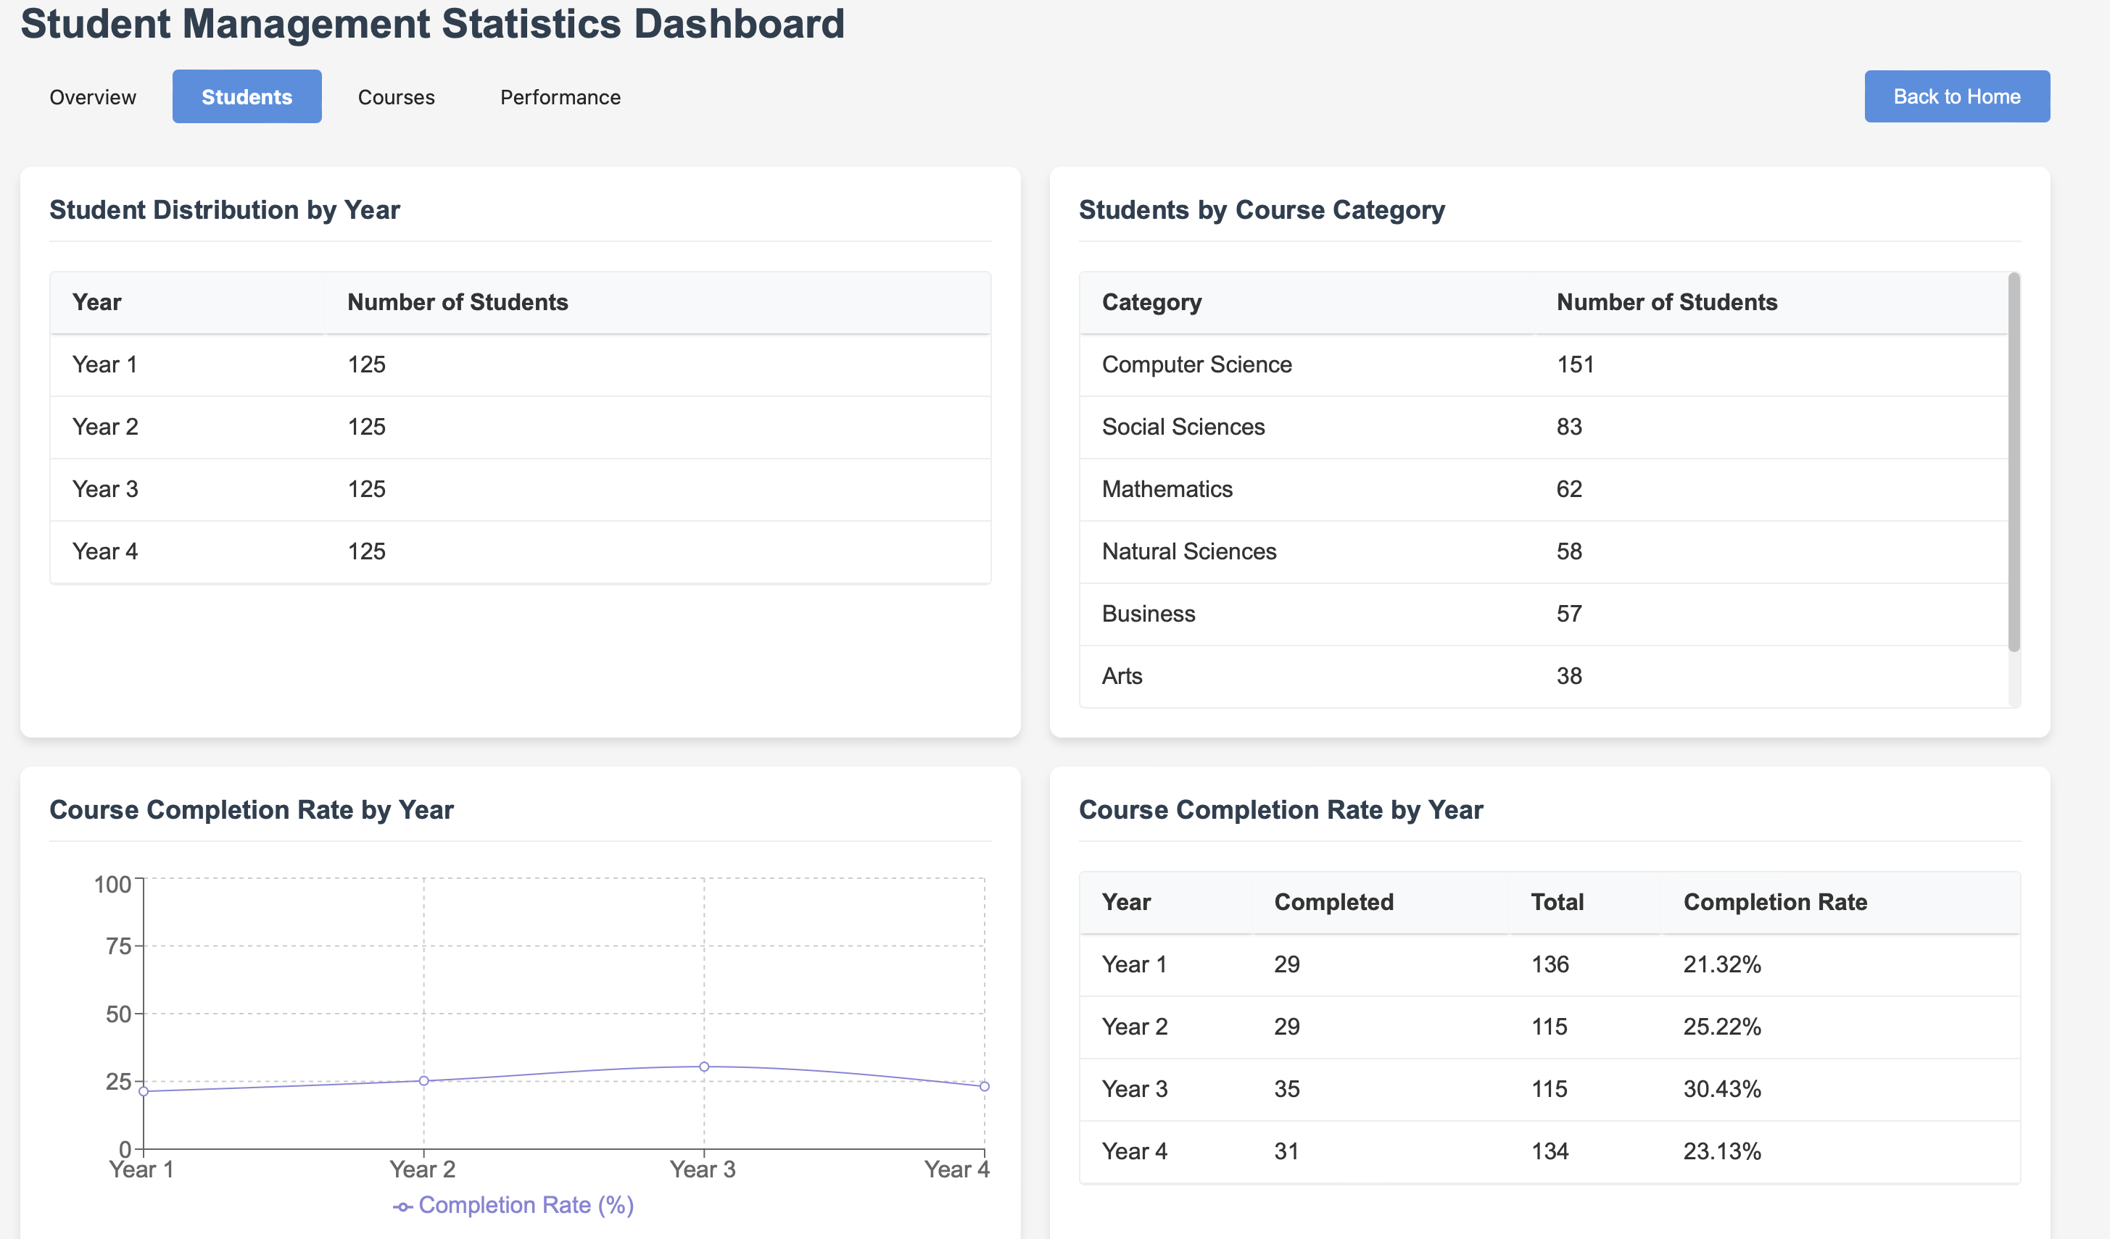

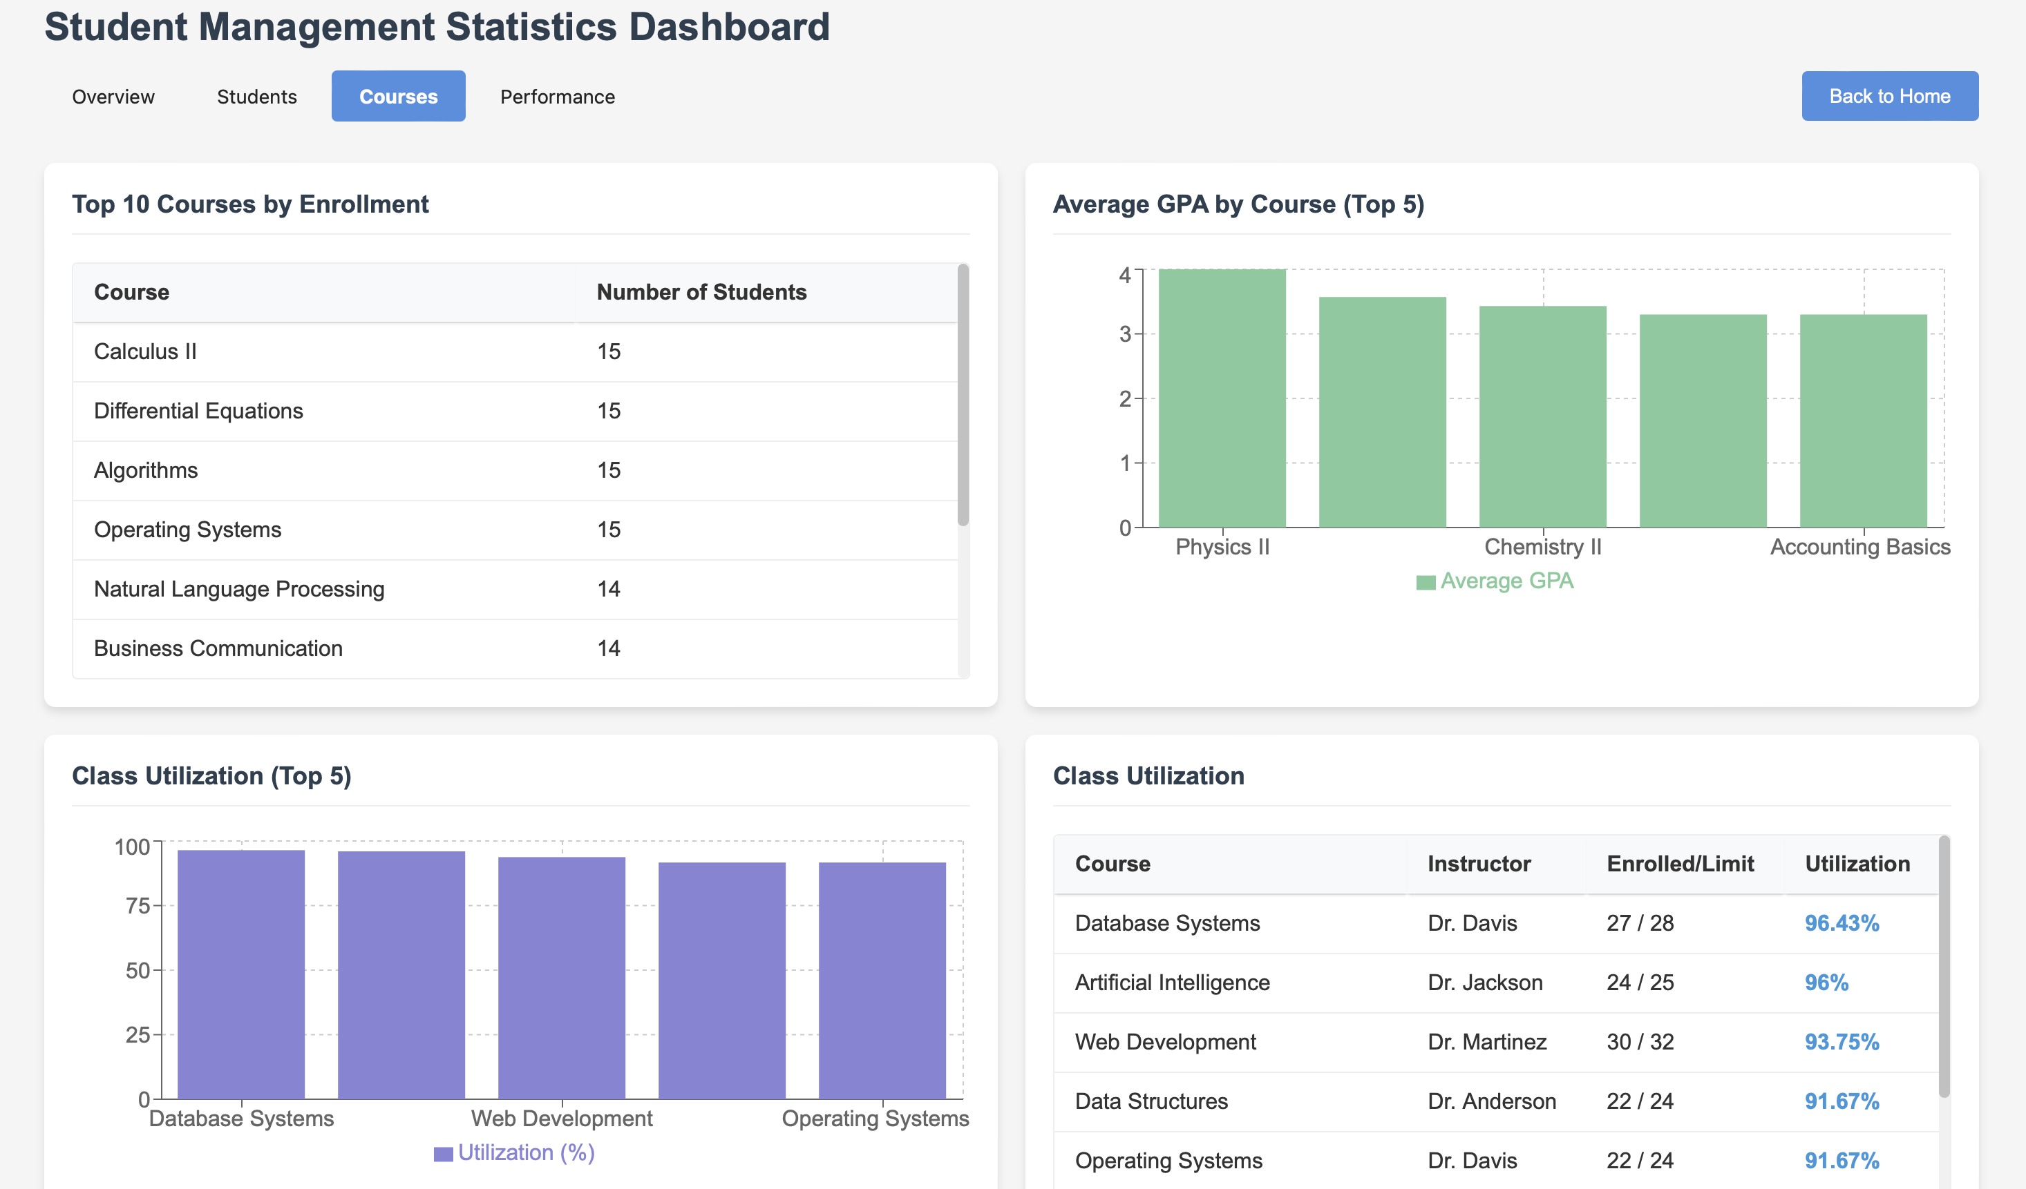

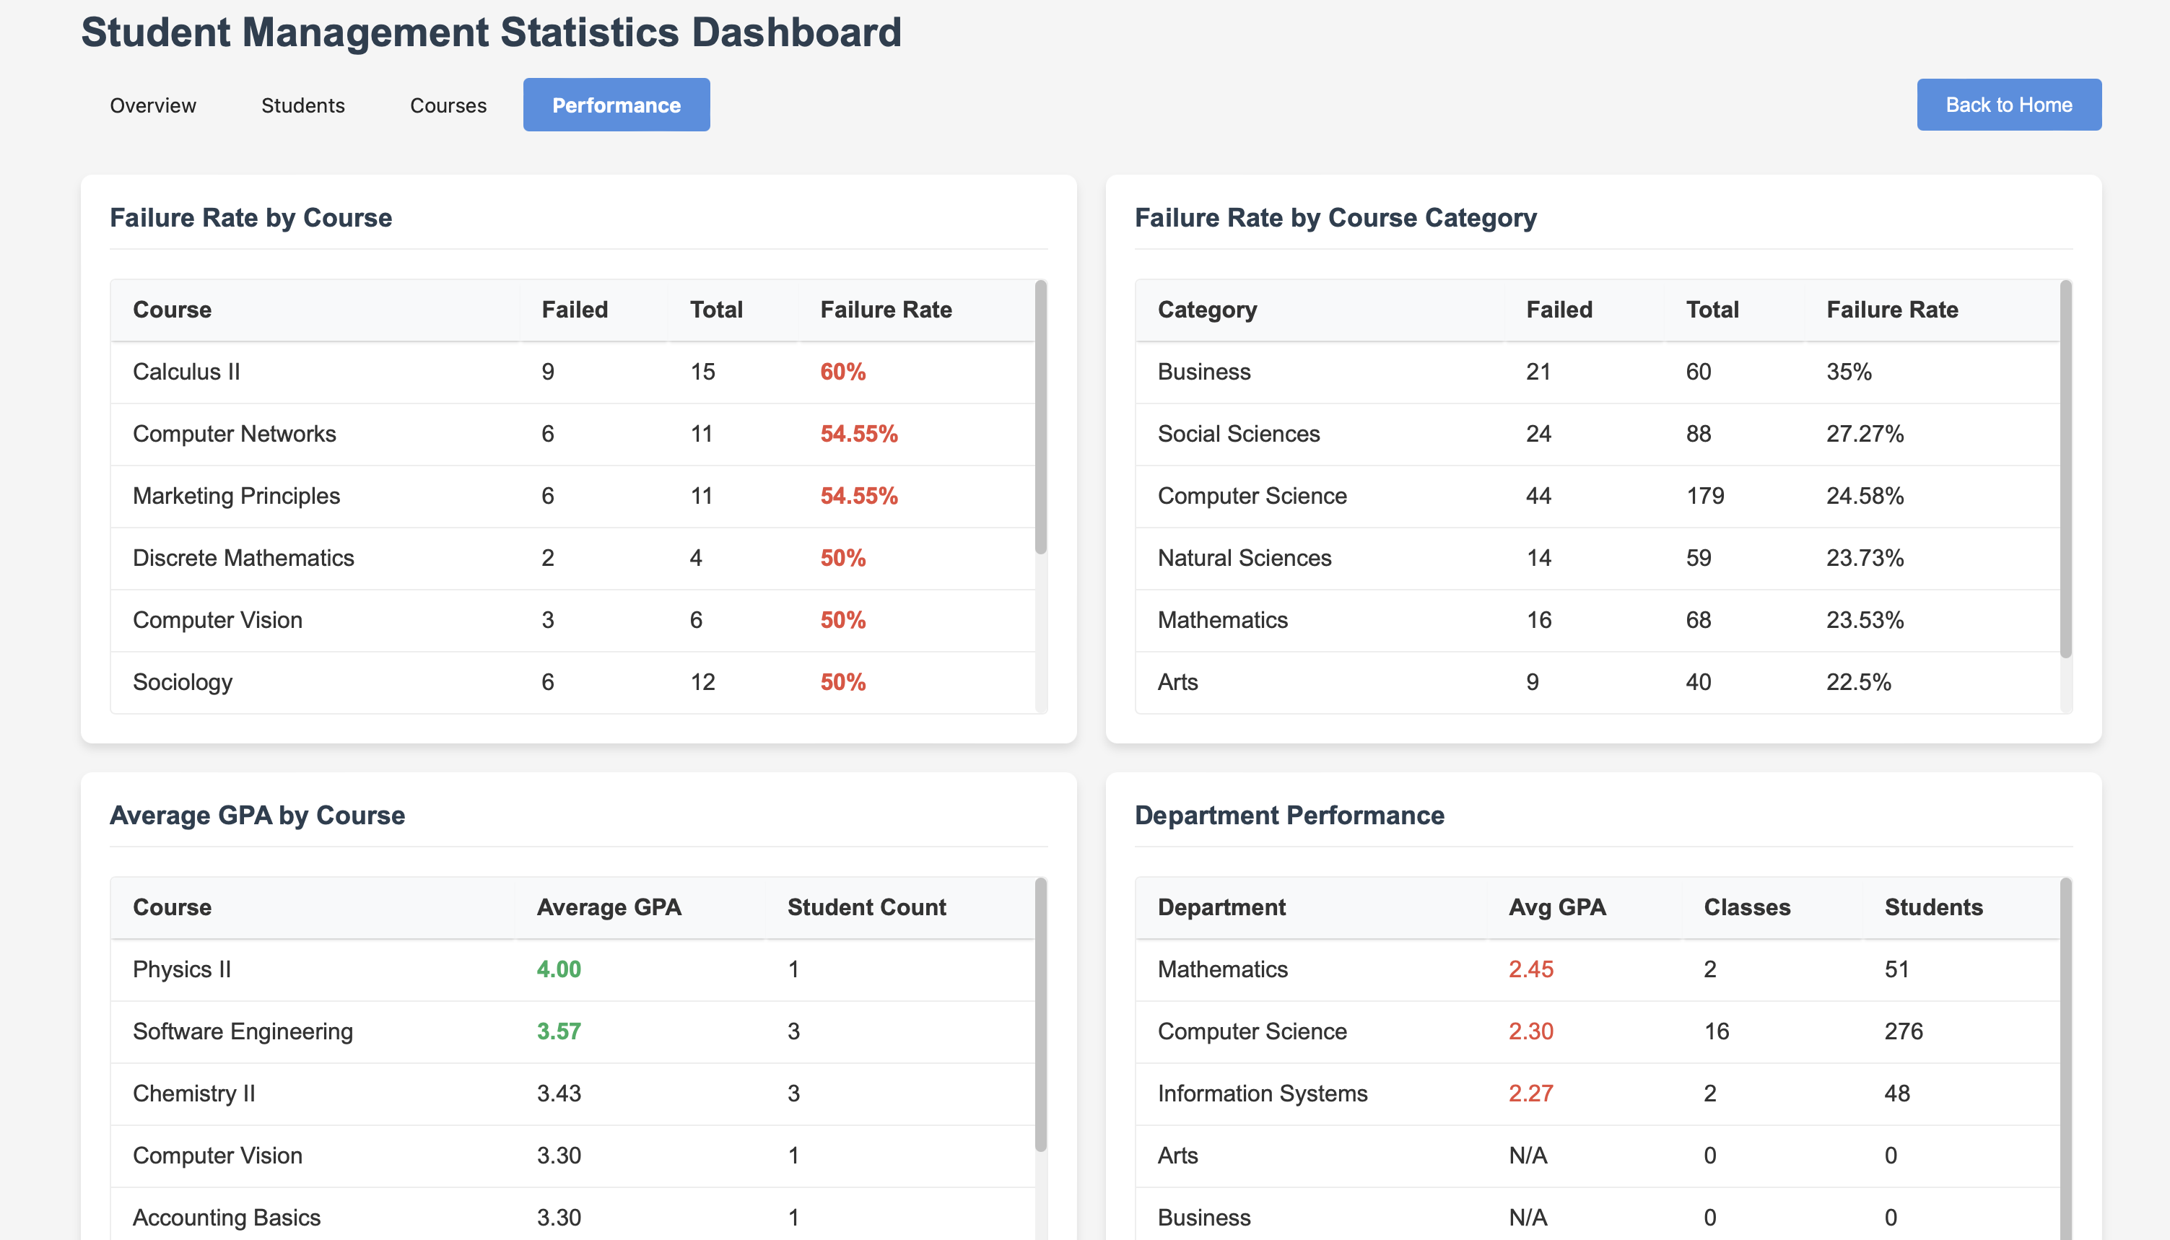

Implemented queries :

Most of the statistics displayed in the dashboard are computed using Prisma queries and loaded into the frontend using the following state structure in the StatisticsDashboard React component:

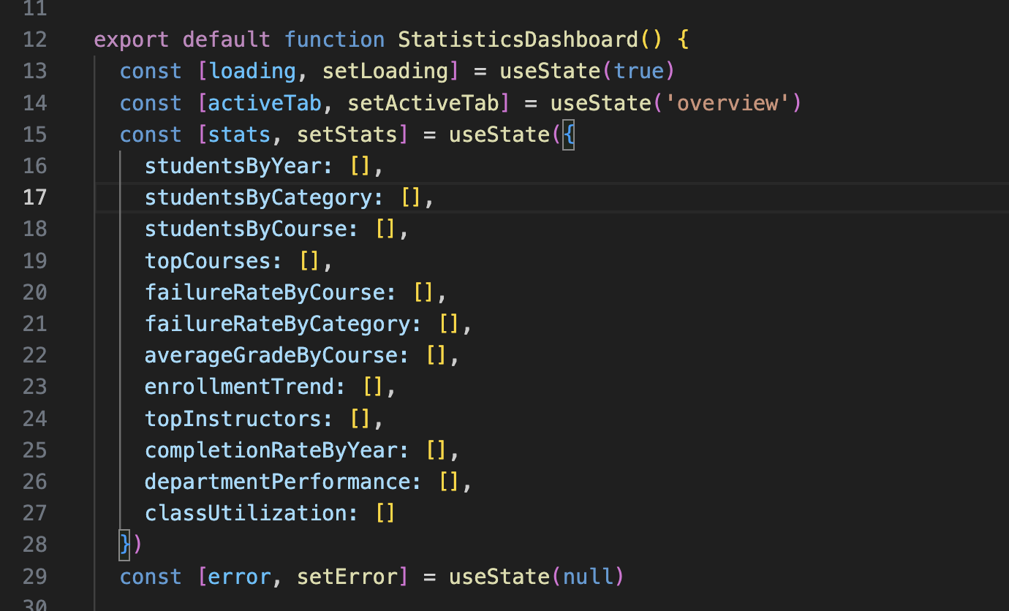

Each of these arrays represents a different type of statistic retrieved from the database, such as:
- studentsByYear: number of students in each academic year
- topCourses: most popular courses by enrollment
- failureRateByCategory: failure percentage by course category
- departmentPerformance: summary of GPA and classes per department

Data used in the statics:

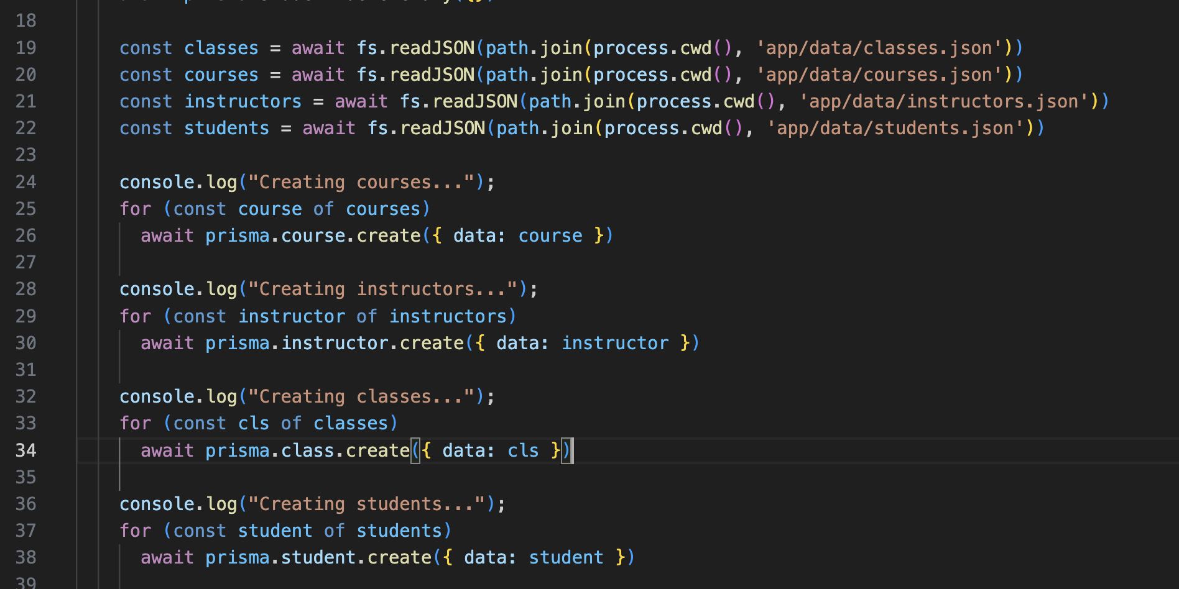

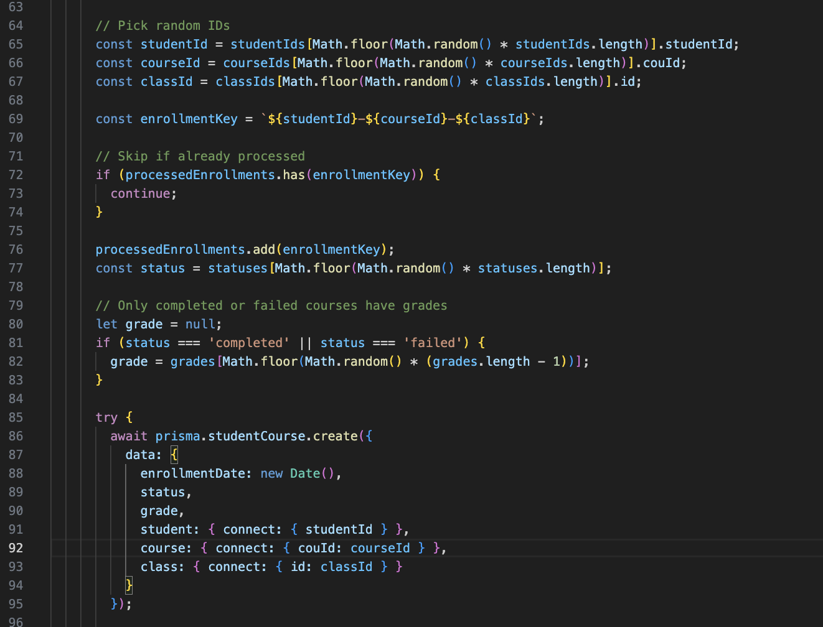

Conducted tests
Prisma Studio

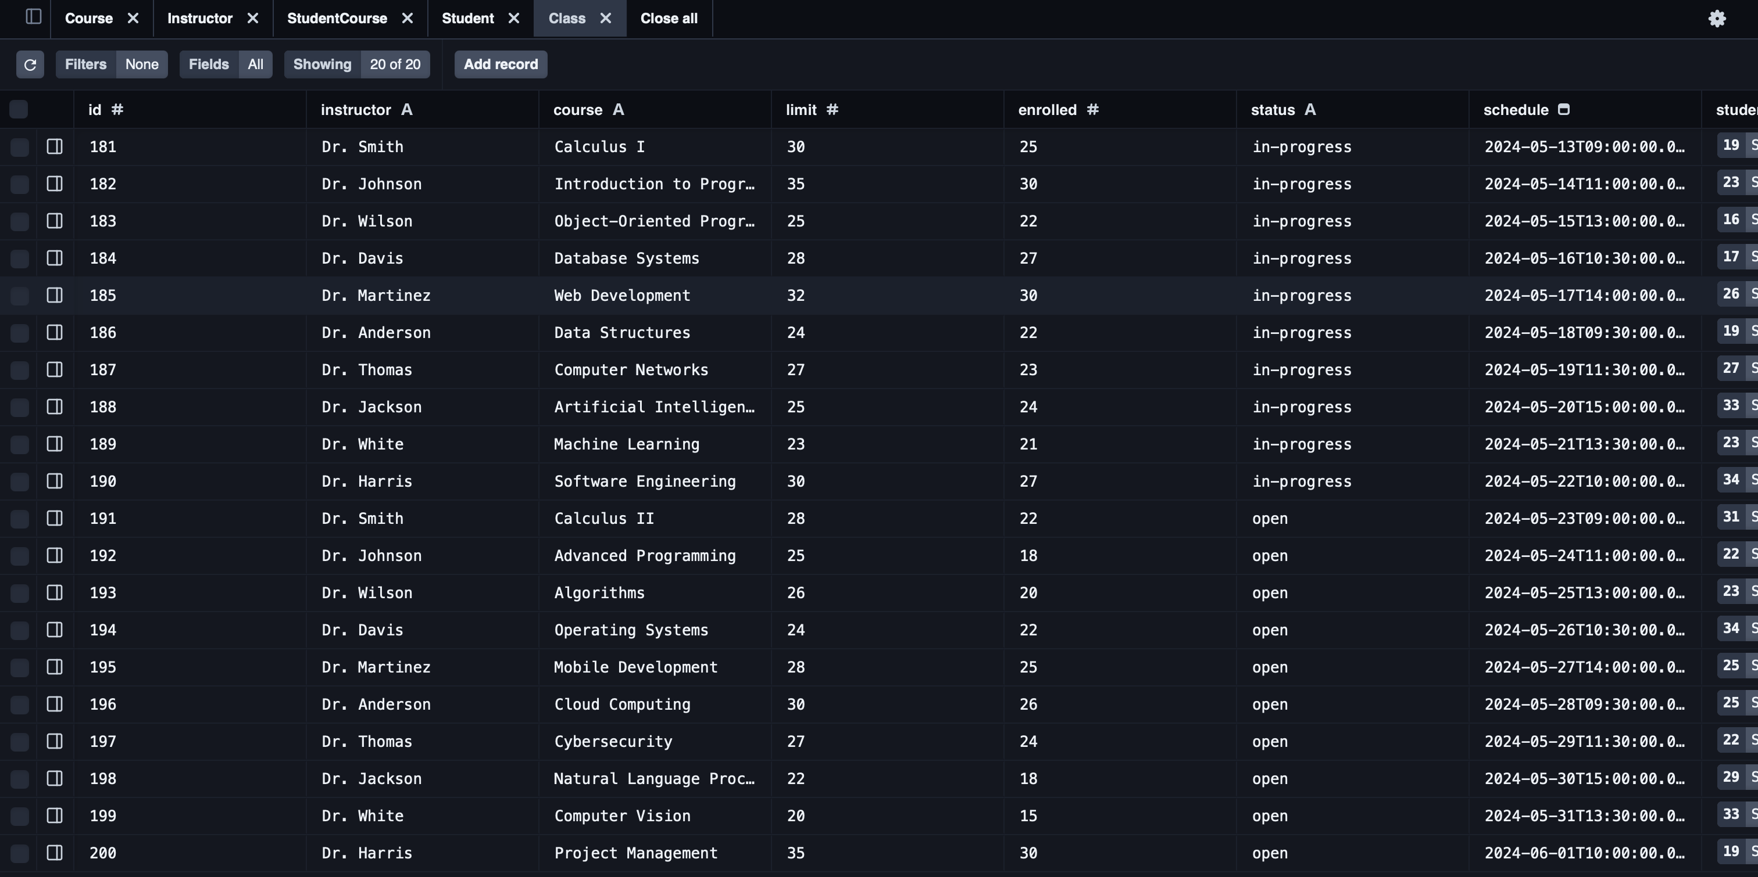

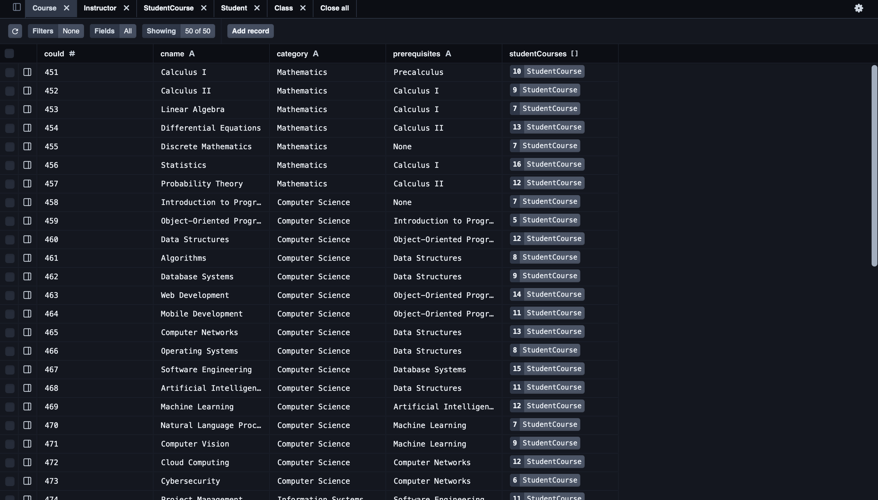

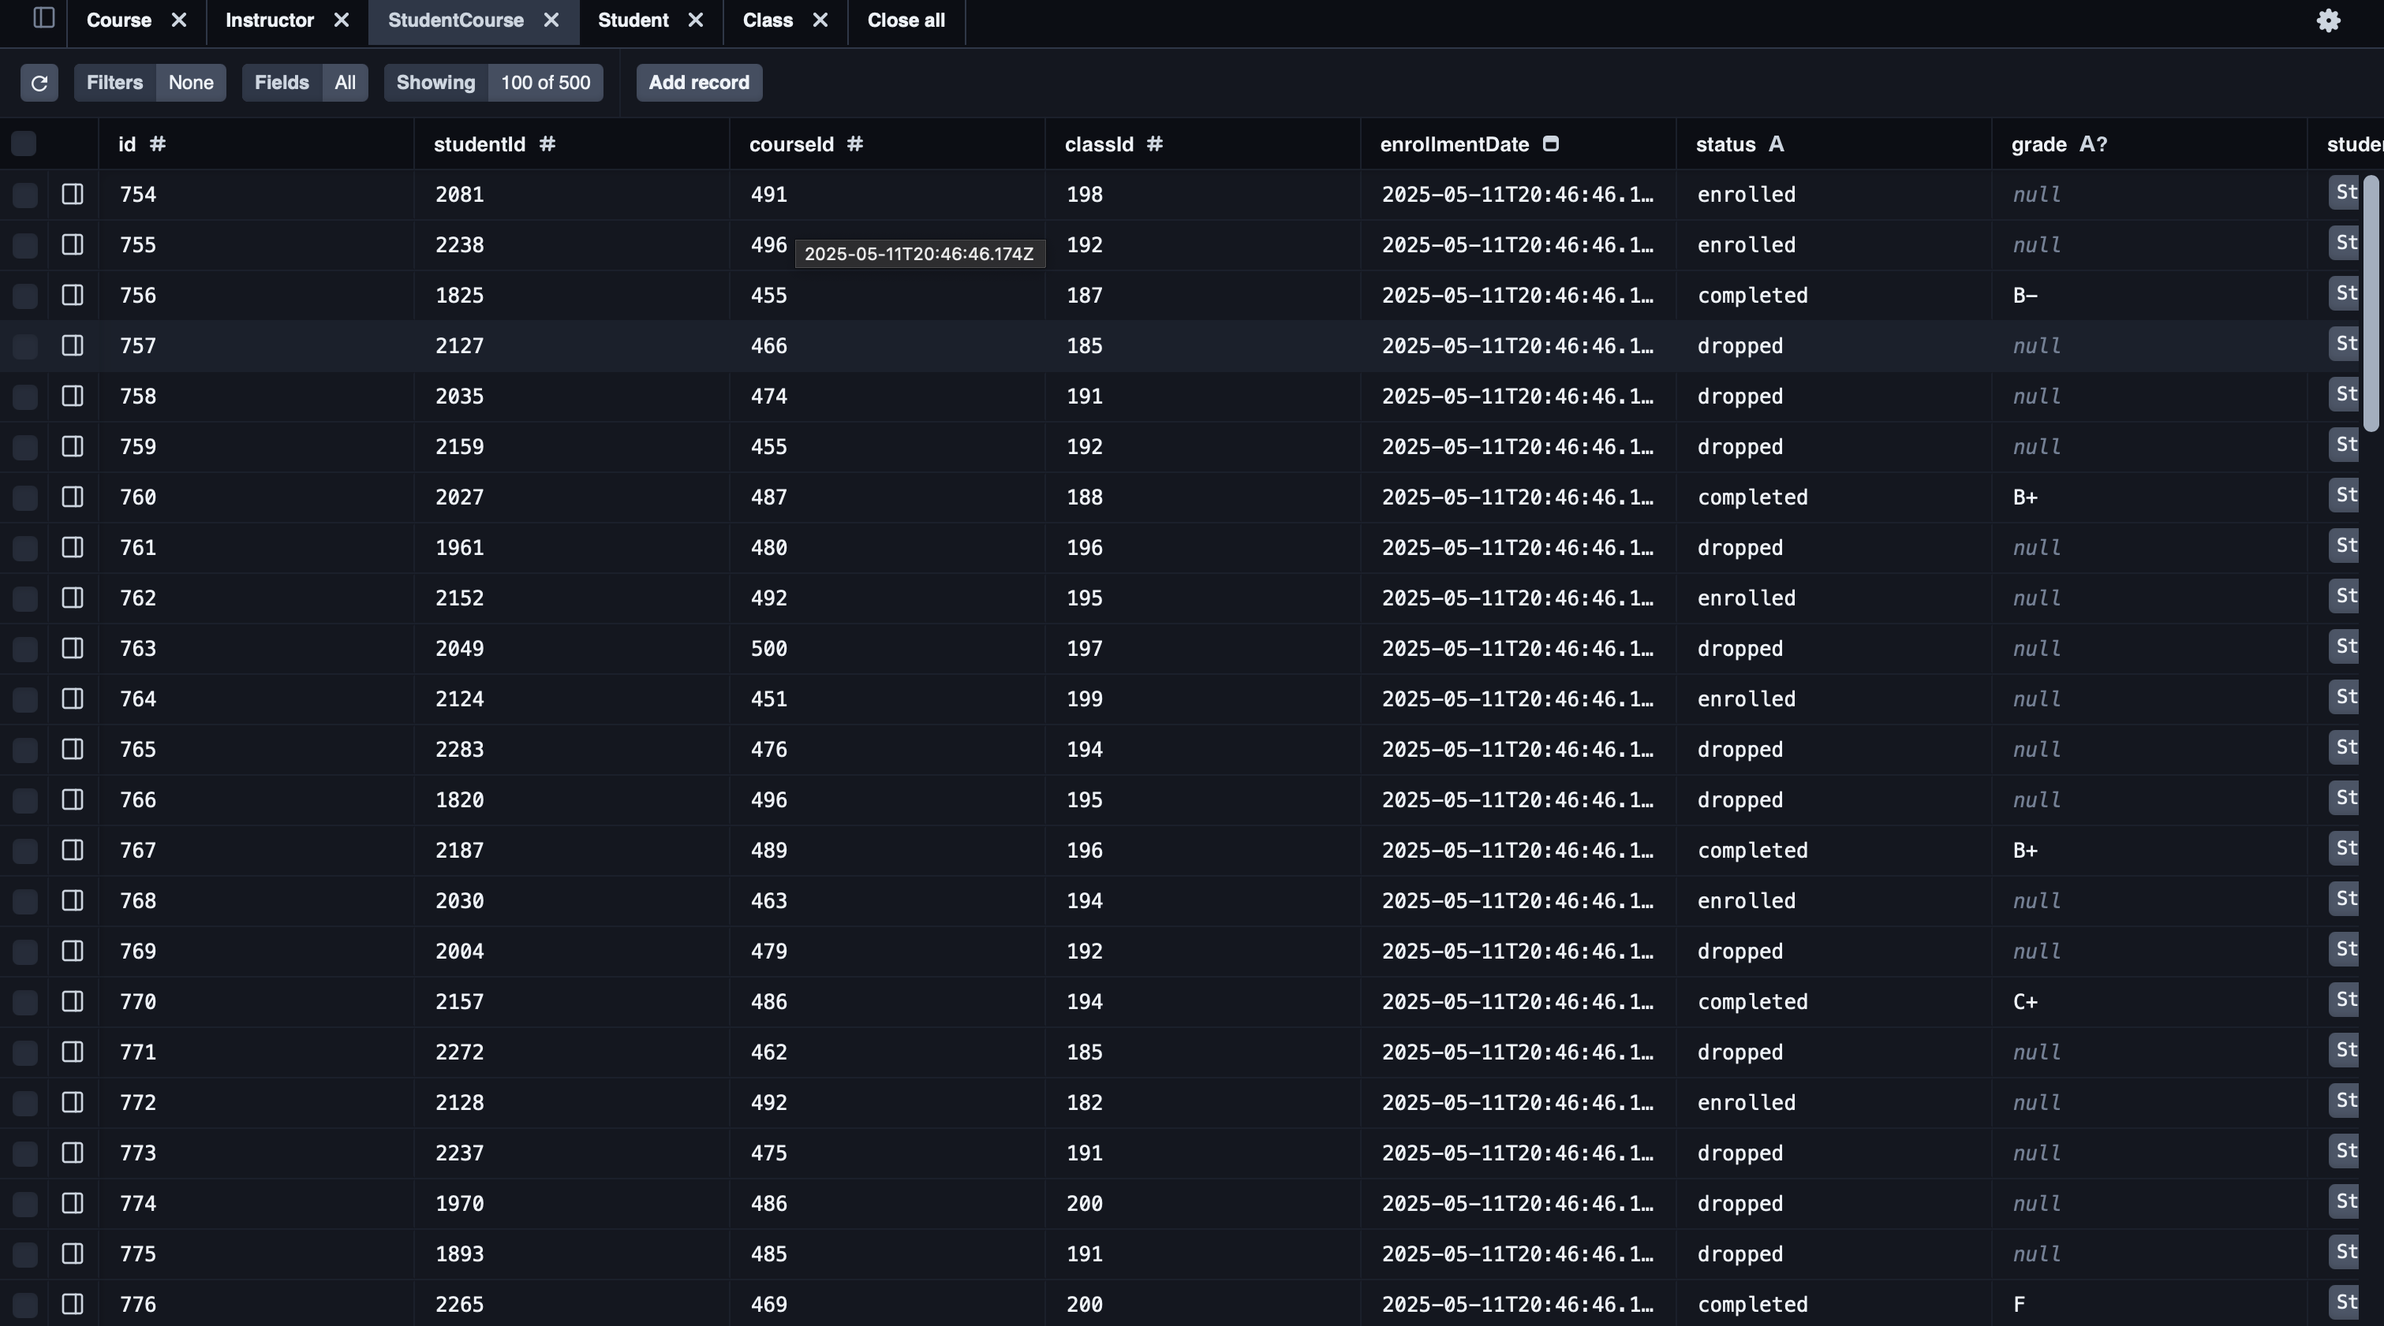

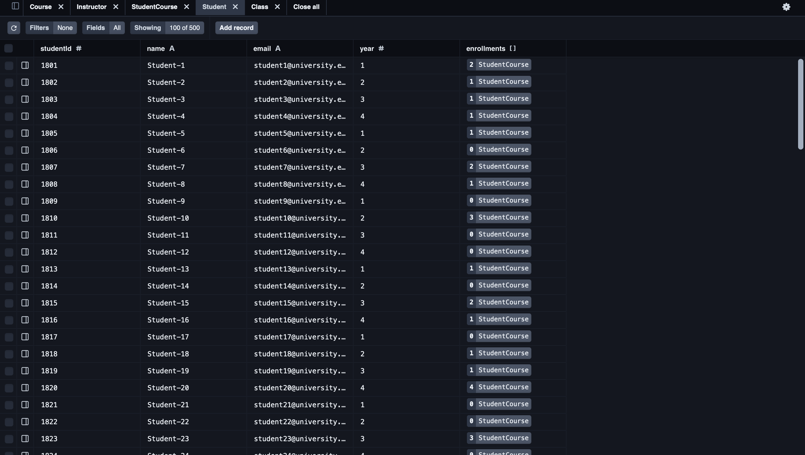

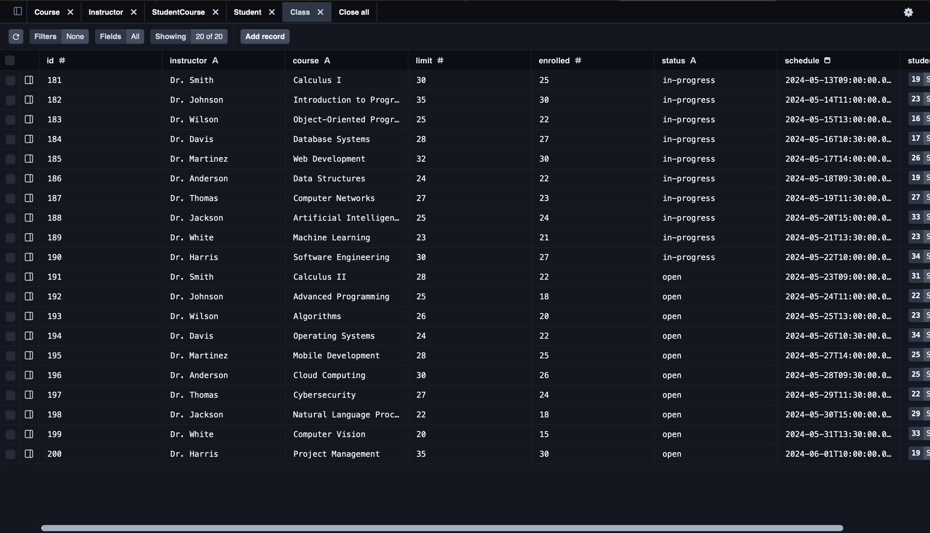

Testing the Web API
- GET app/api/class
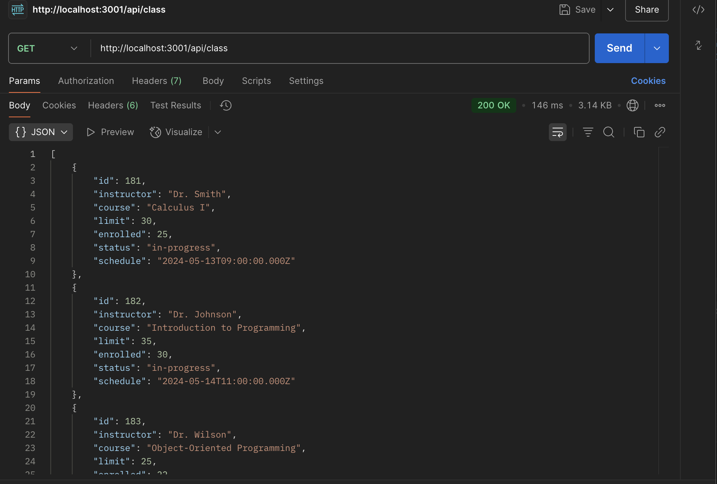
- app/api/class
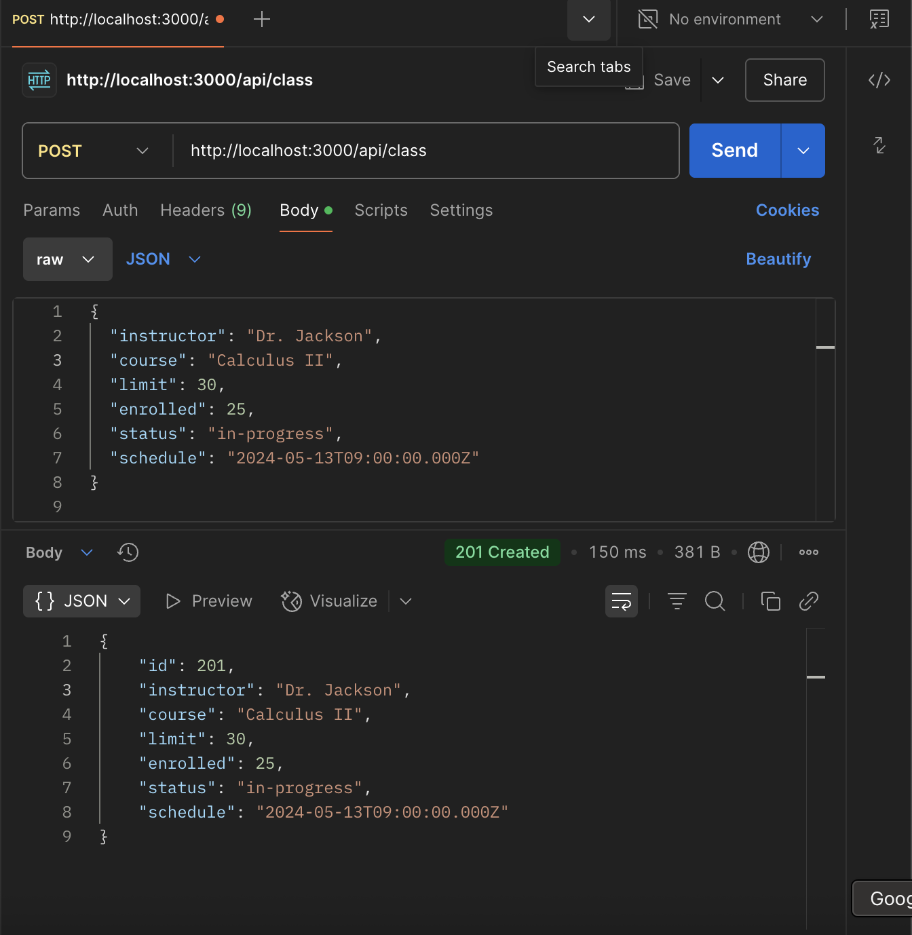

- GET app/api/course – get all courses
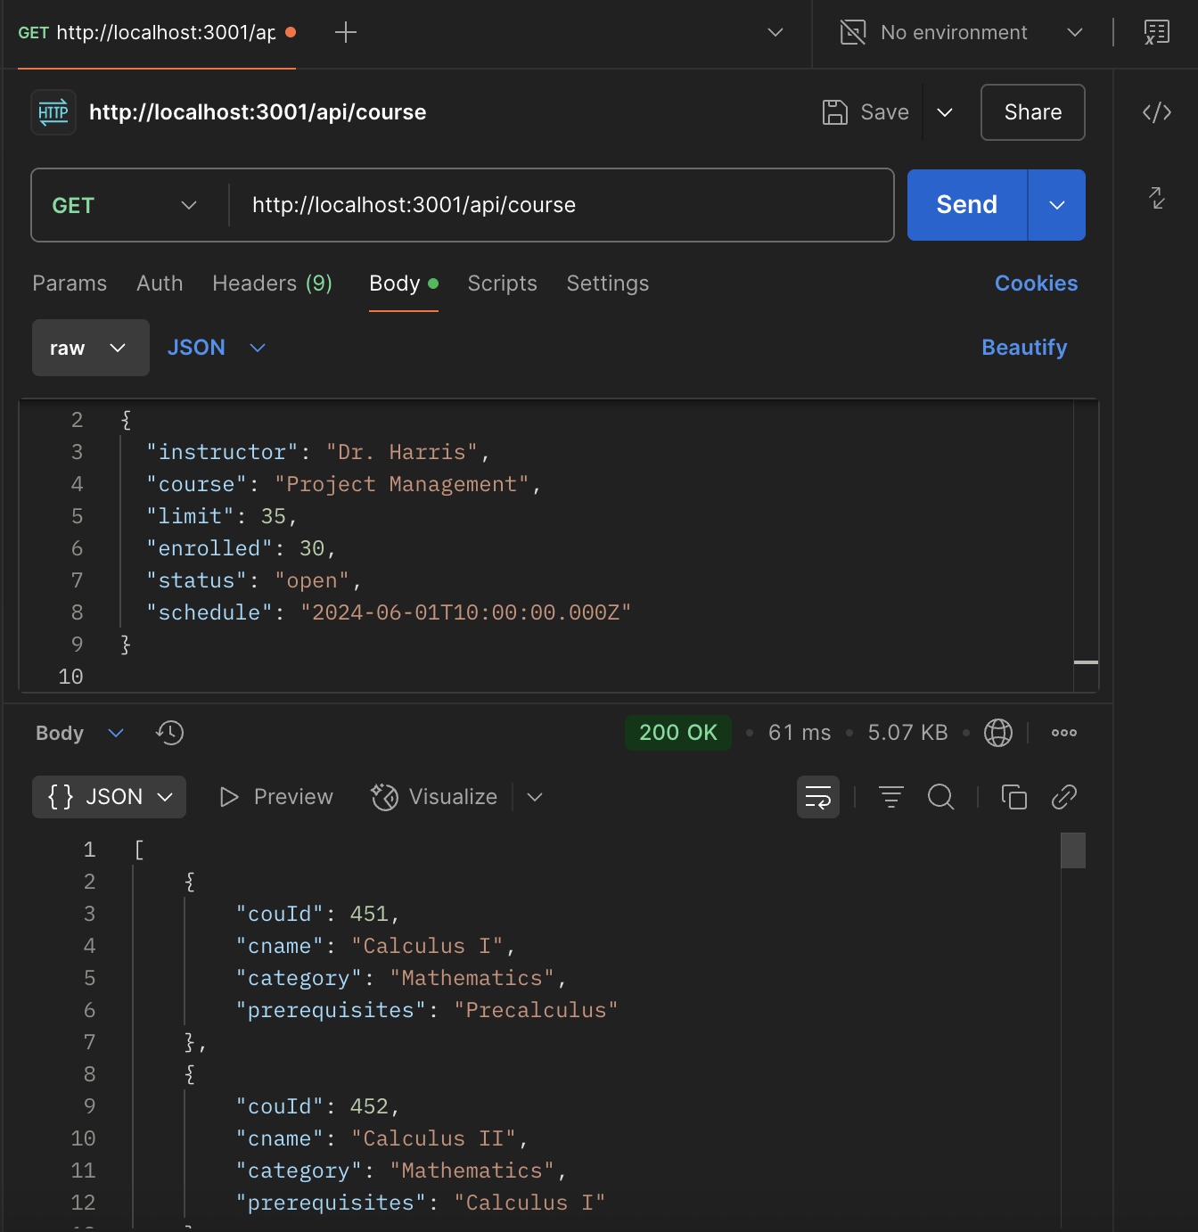

- POST app/api/course – creates course
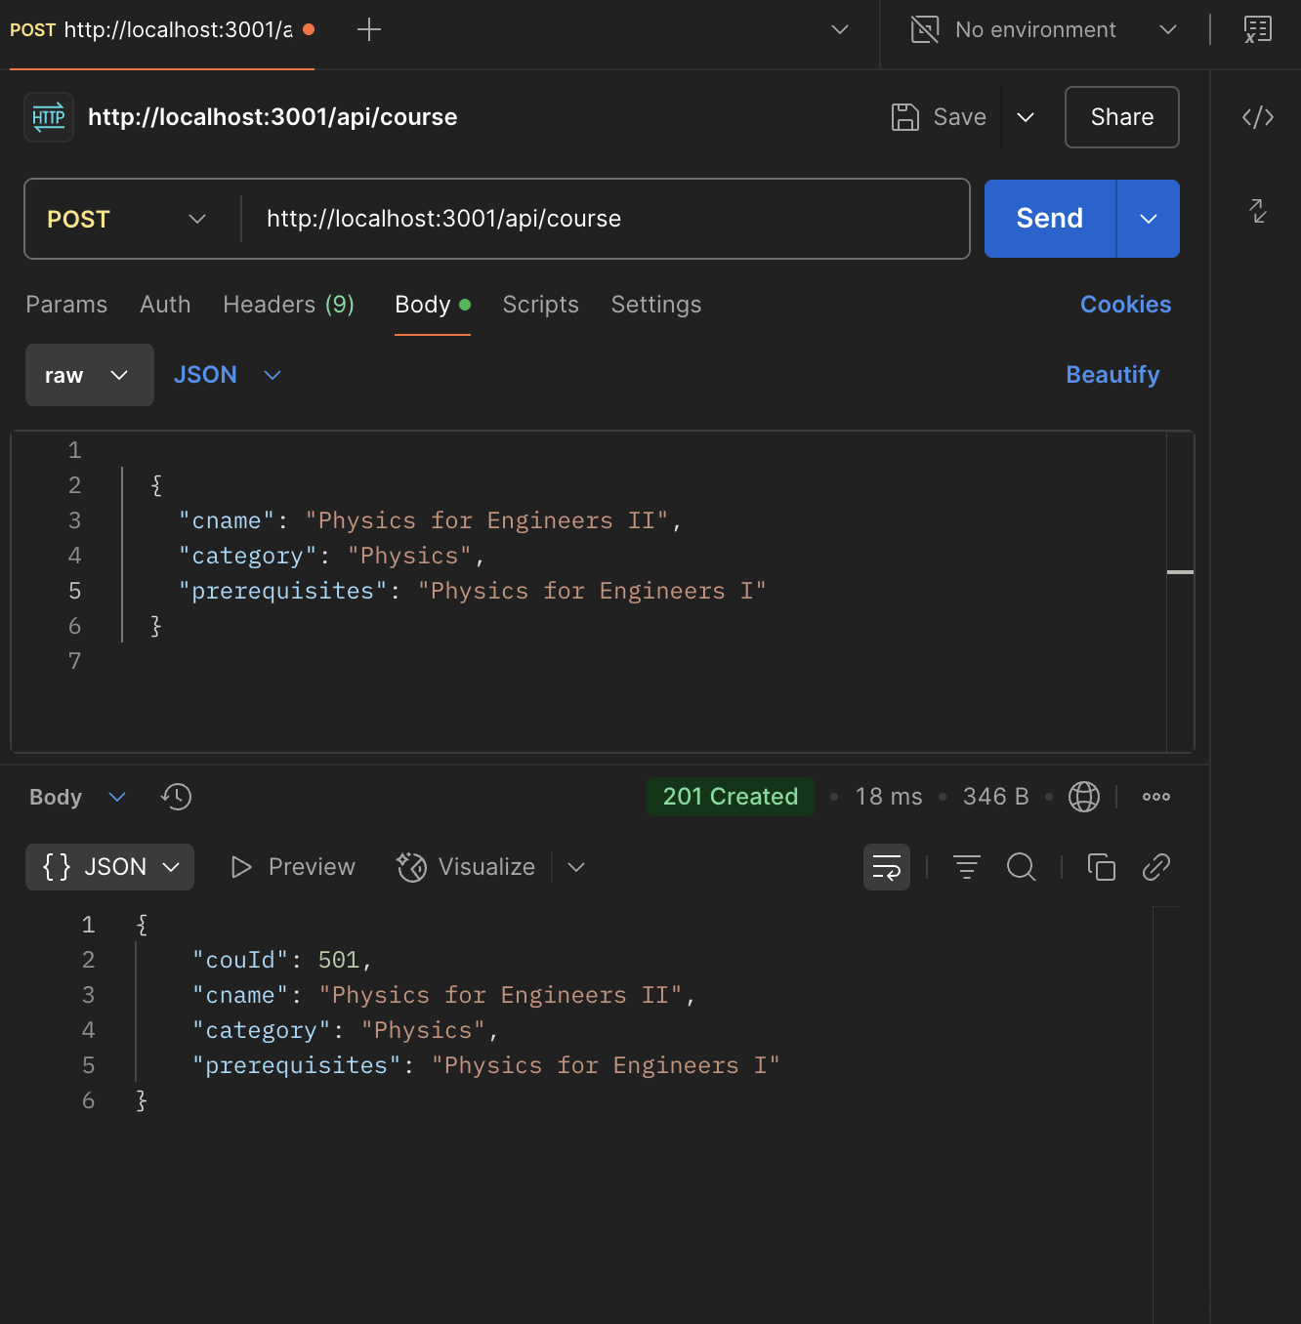

- GET app/api/course/[category] – gets course by category
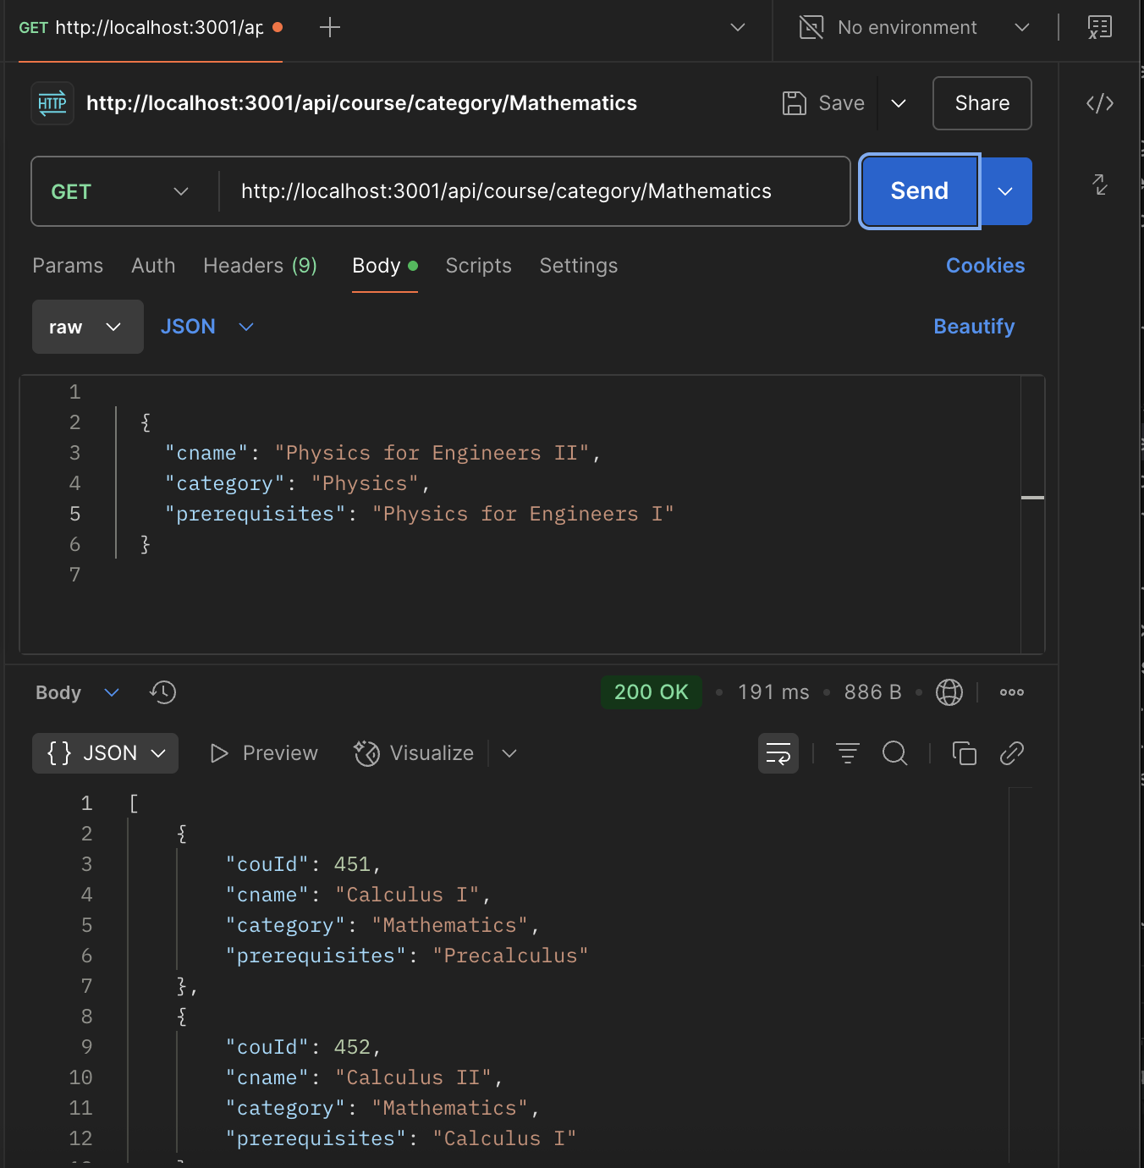

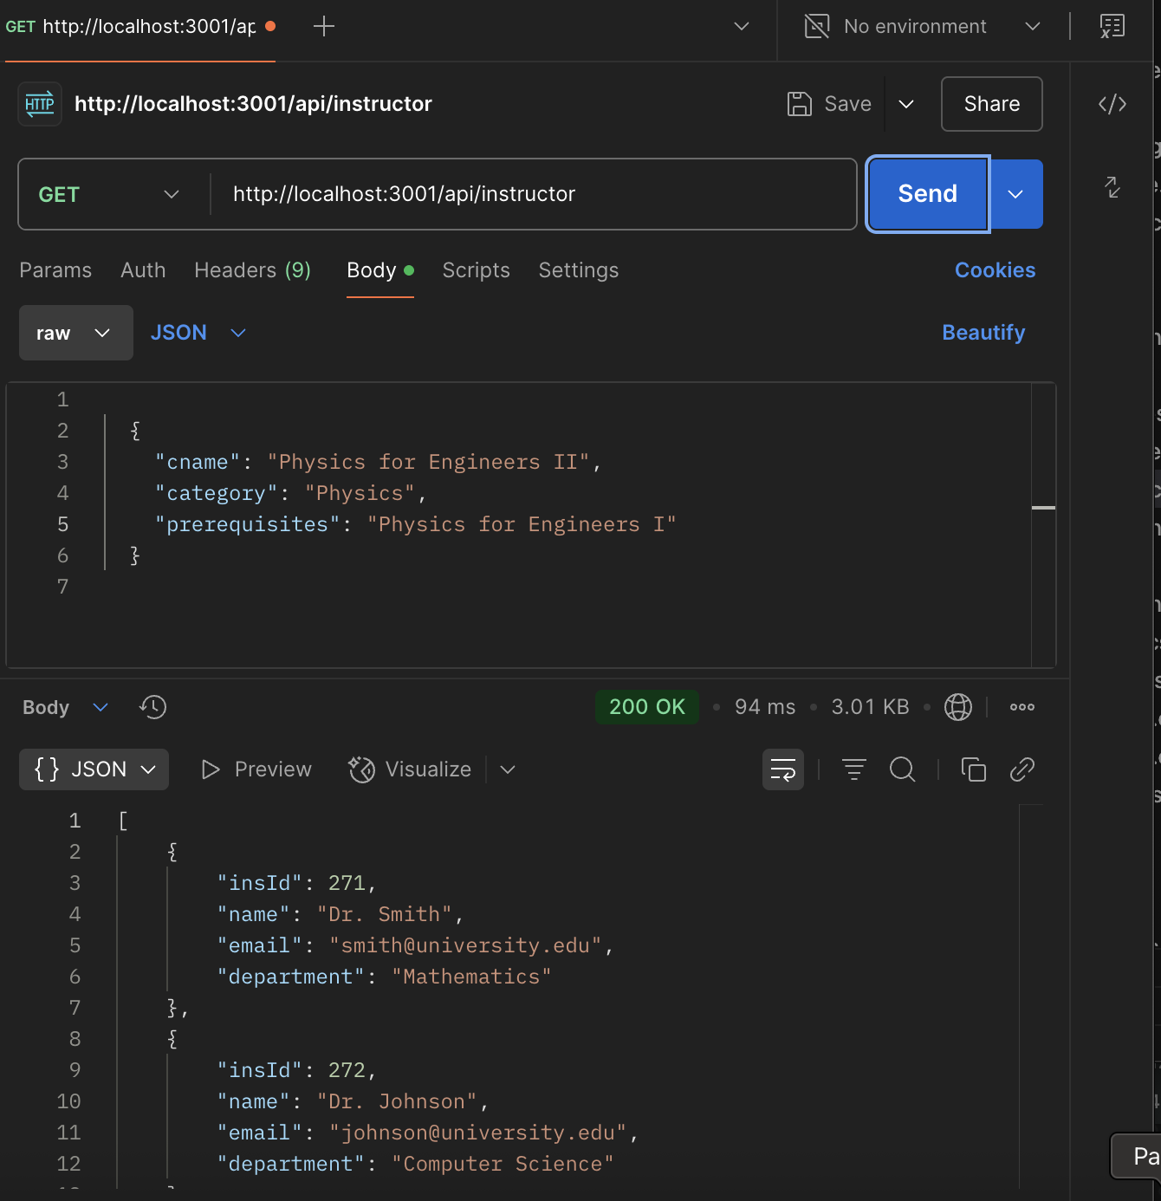
- GET app/api/instructor – gets all instructors

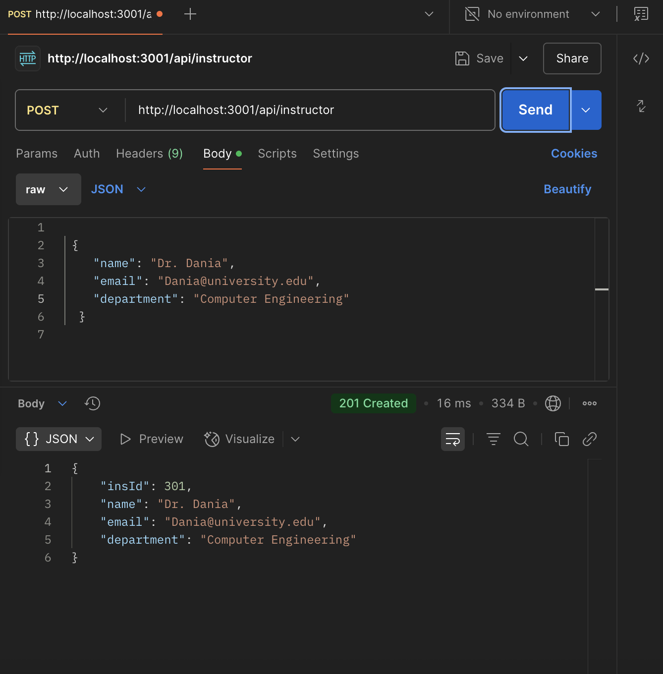
- POST app/api/instructor – creates instructor

- GET app/api/instructor/[id] – get a instructor
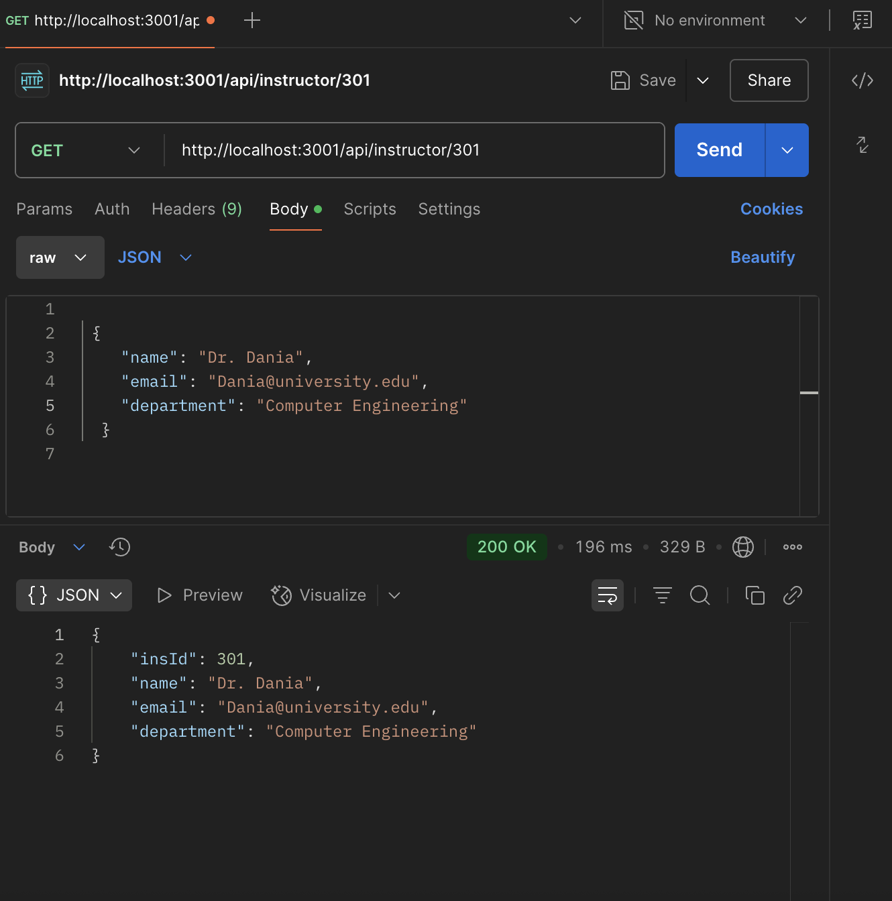

- PUT app/api/instructor/[id] – update a instructor
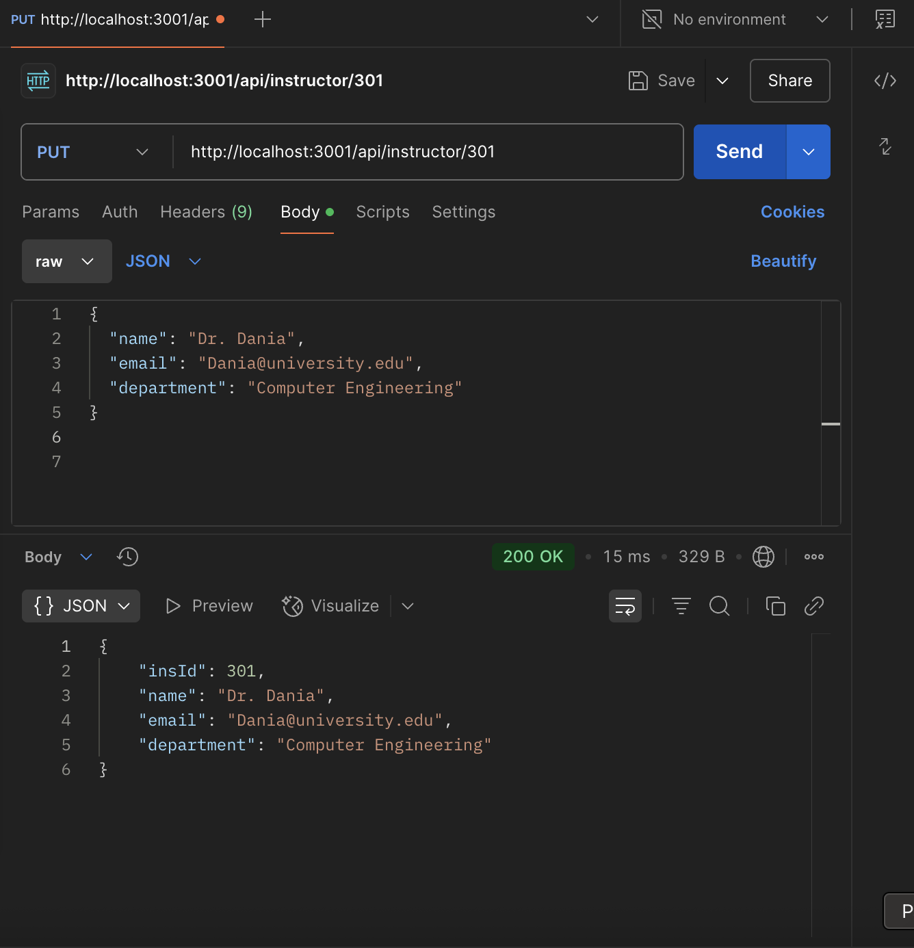

- DELETE app/api/instructor/[id] – delete a instructor
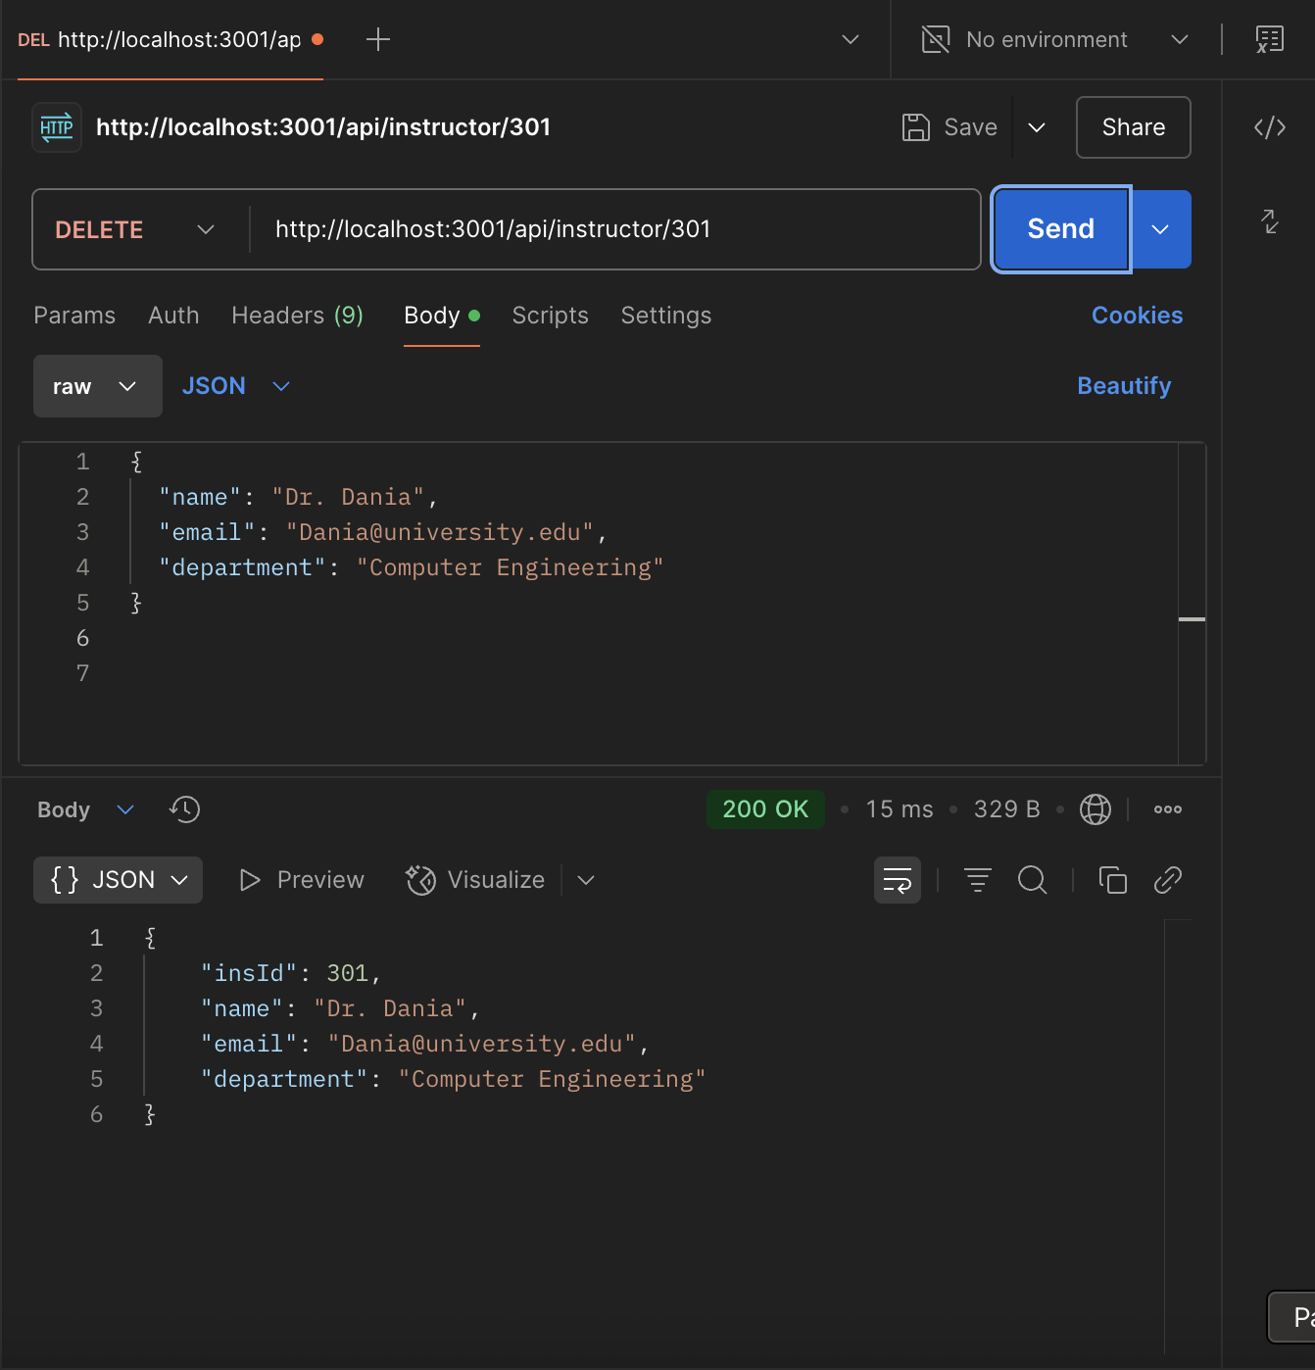

- GET app/api/open – gets all open classes
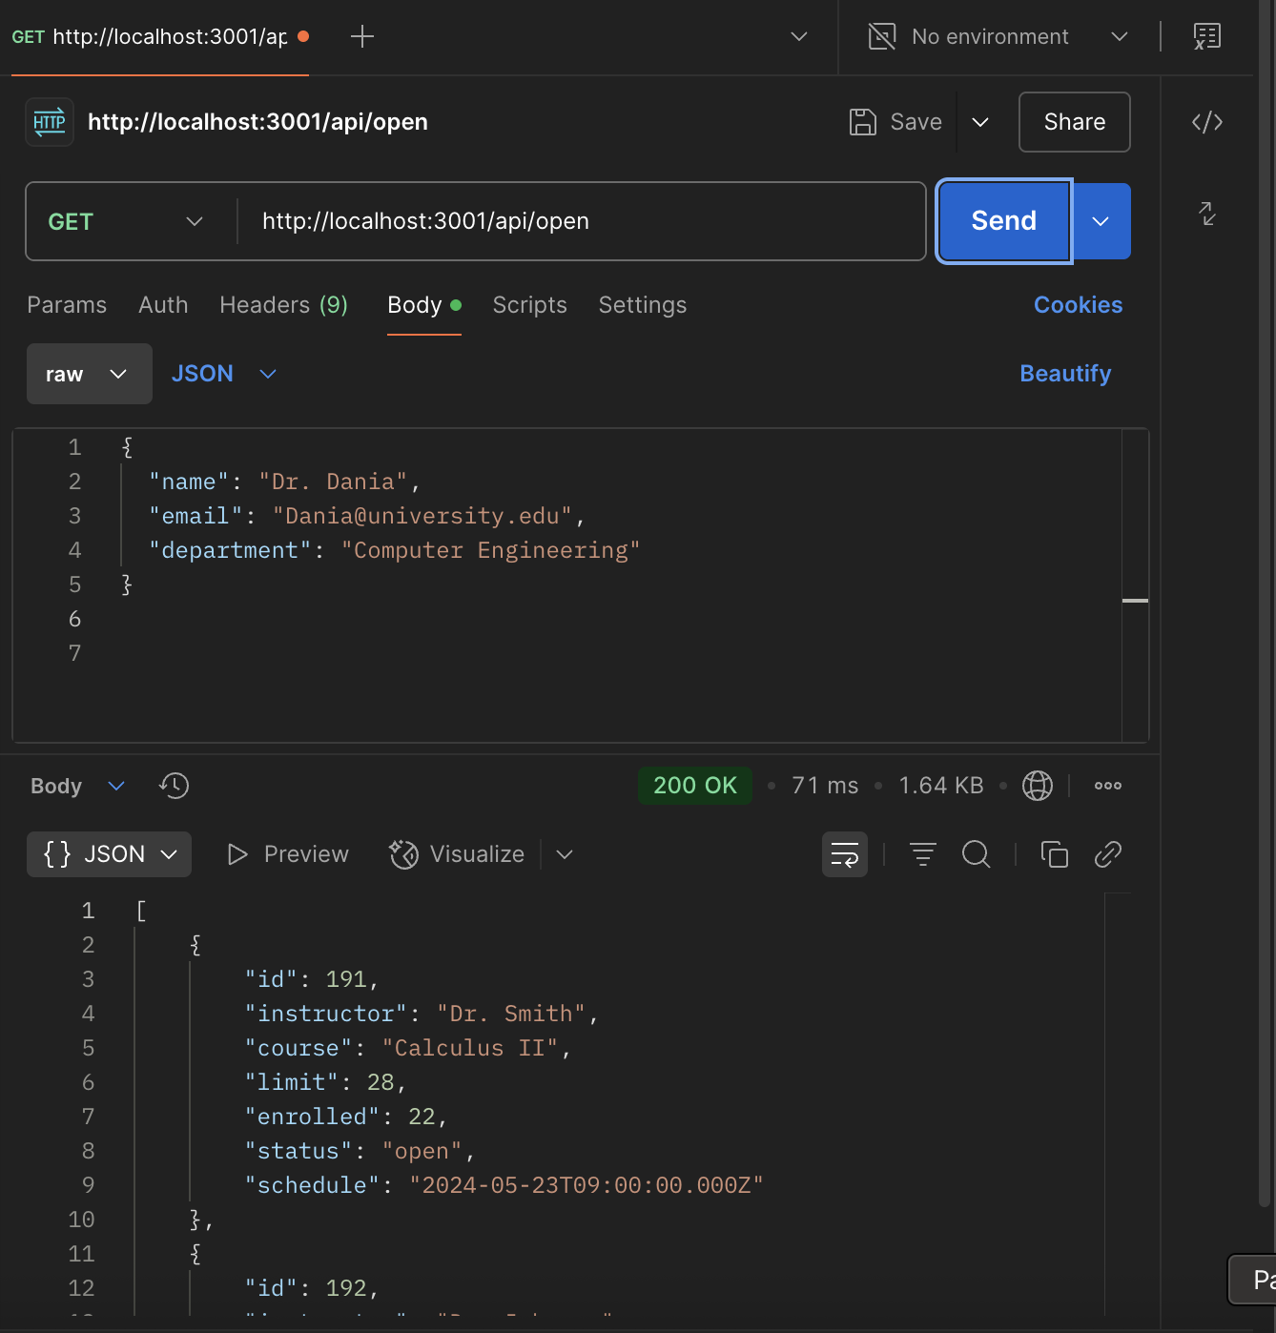

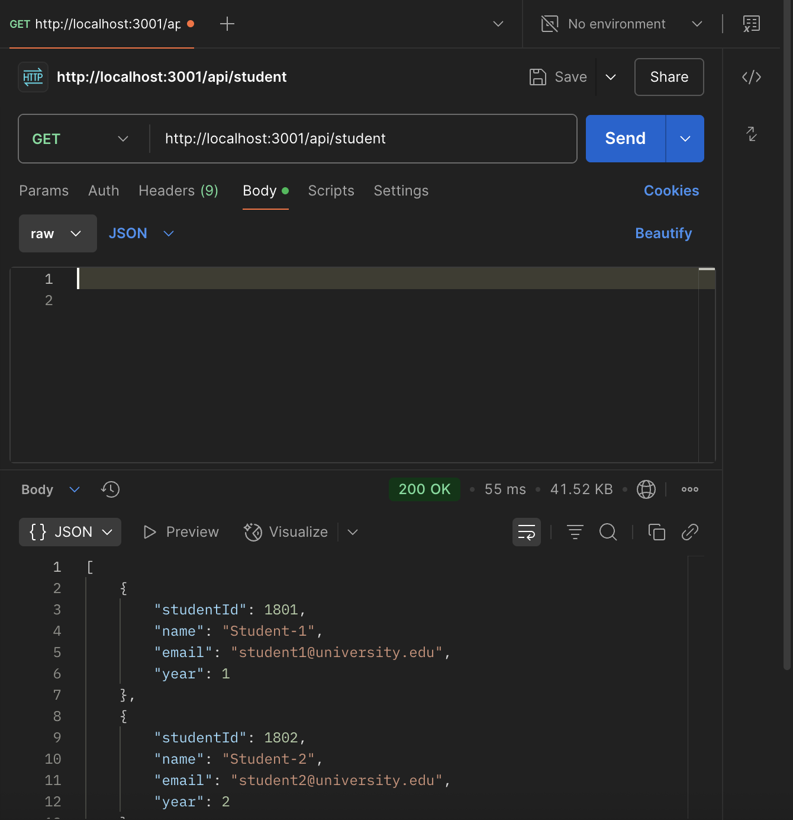
- GET app/api/student – gets all students

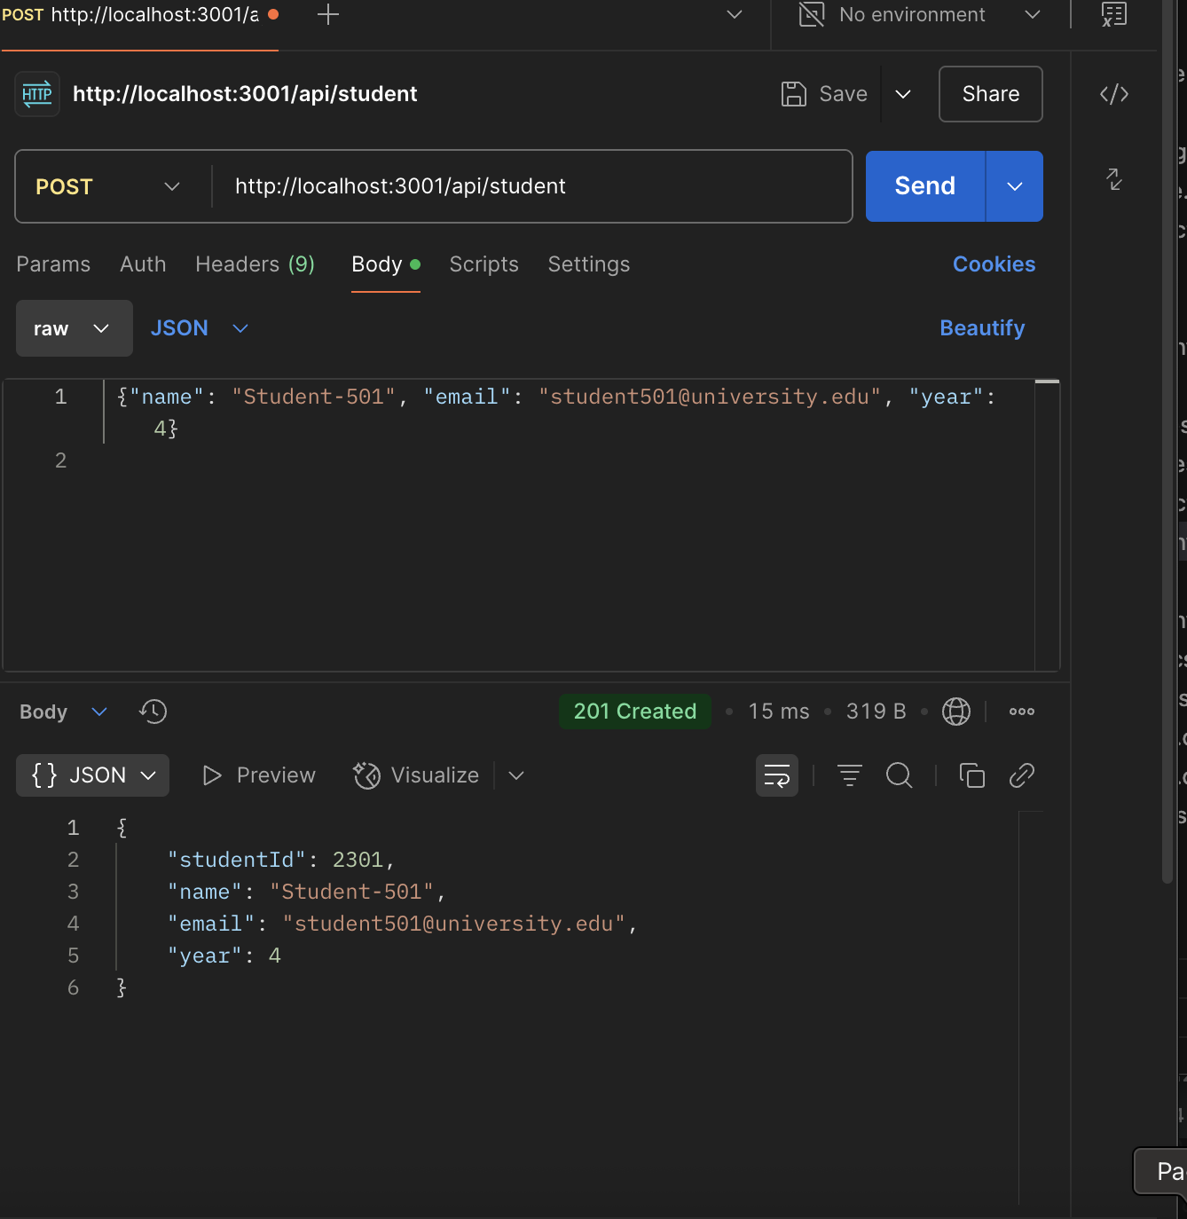
- POST app/api/student – creates student

- GET app/api/student/[id] – get a student
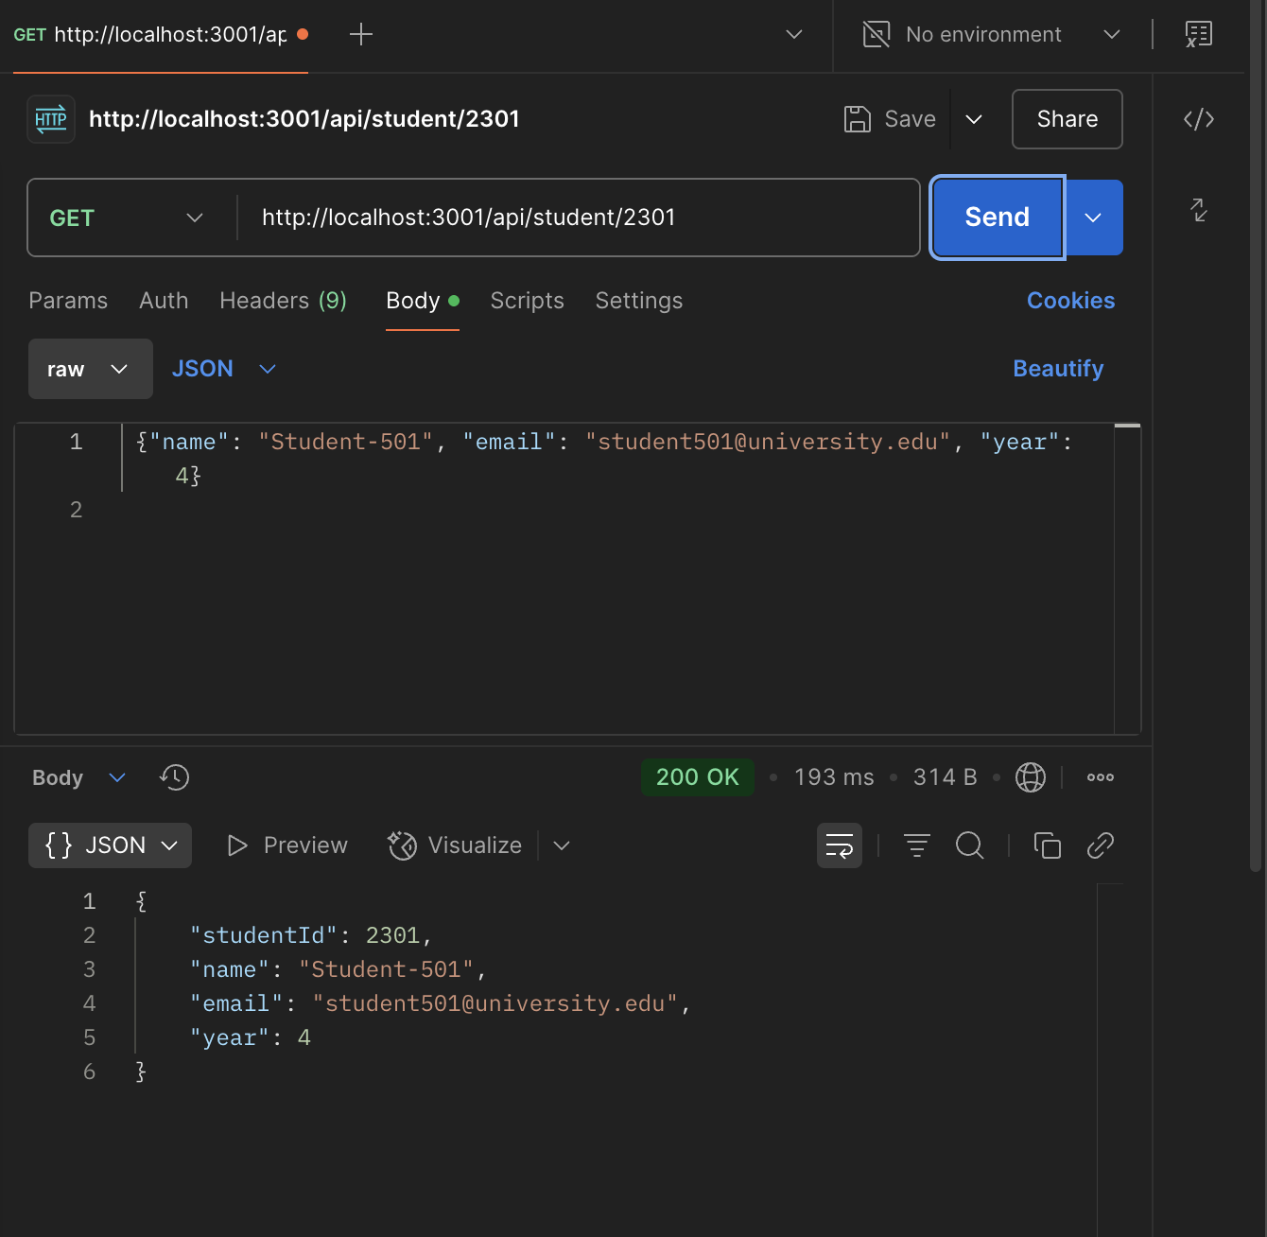

- PUT app/api/student/[id] – update student
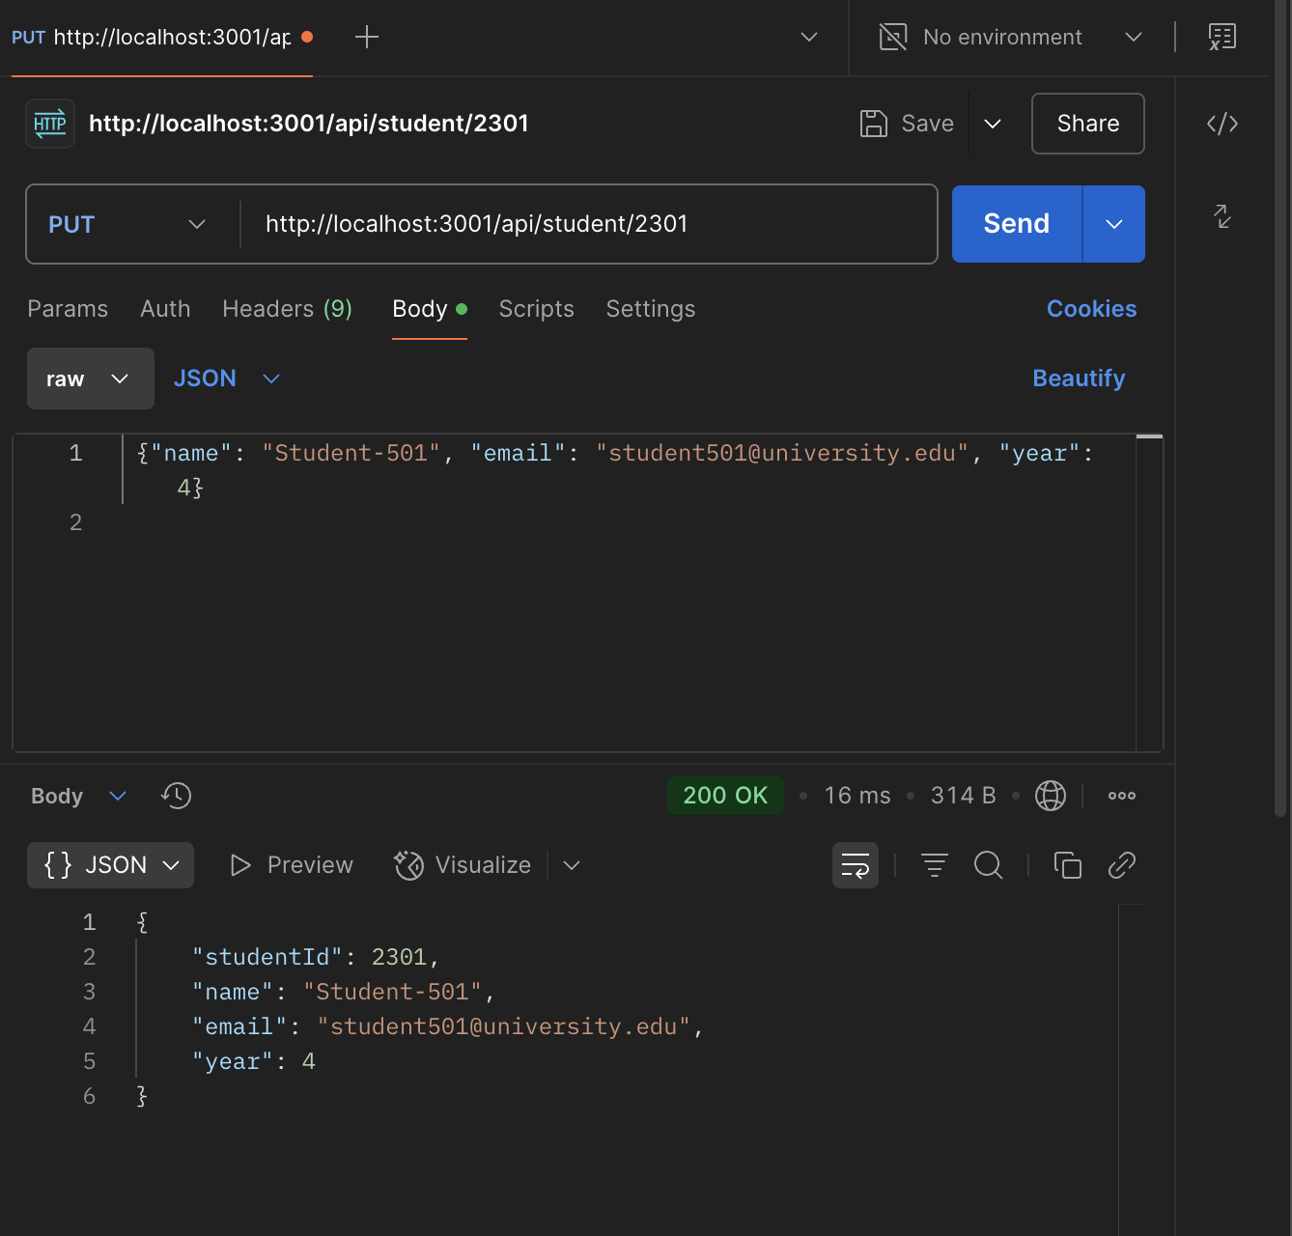

- DELETE app/api/student/[id] – delete student
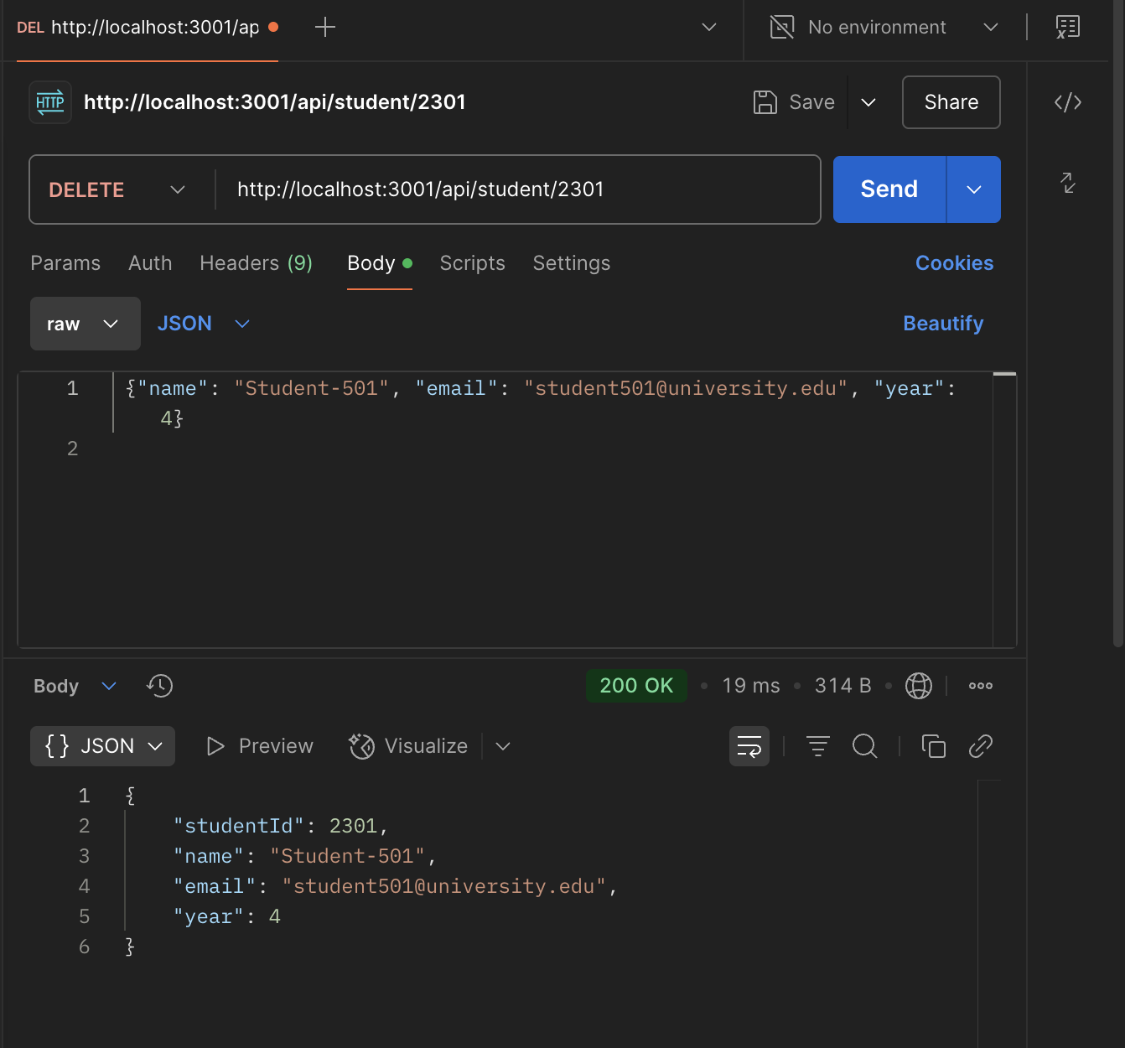

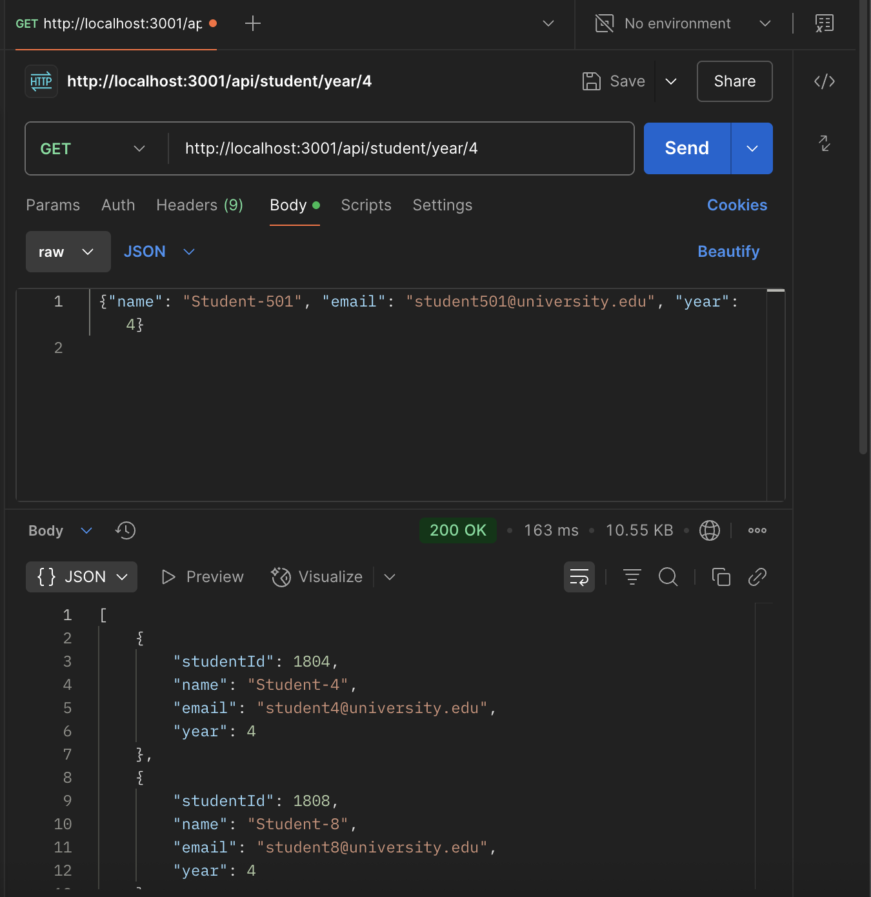
- GET app/api/student/year/[year] – get students by year

- GET app/api/class/[id] – gets a class
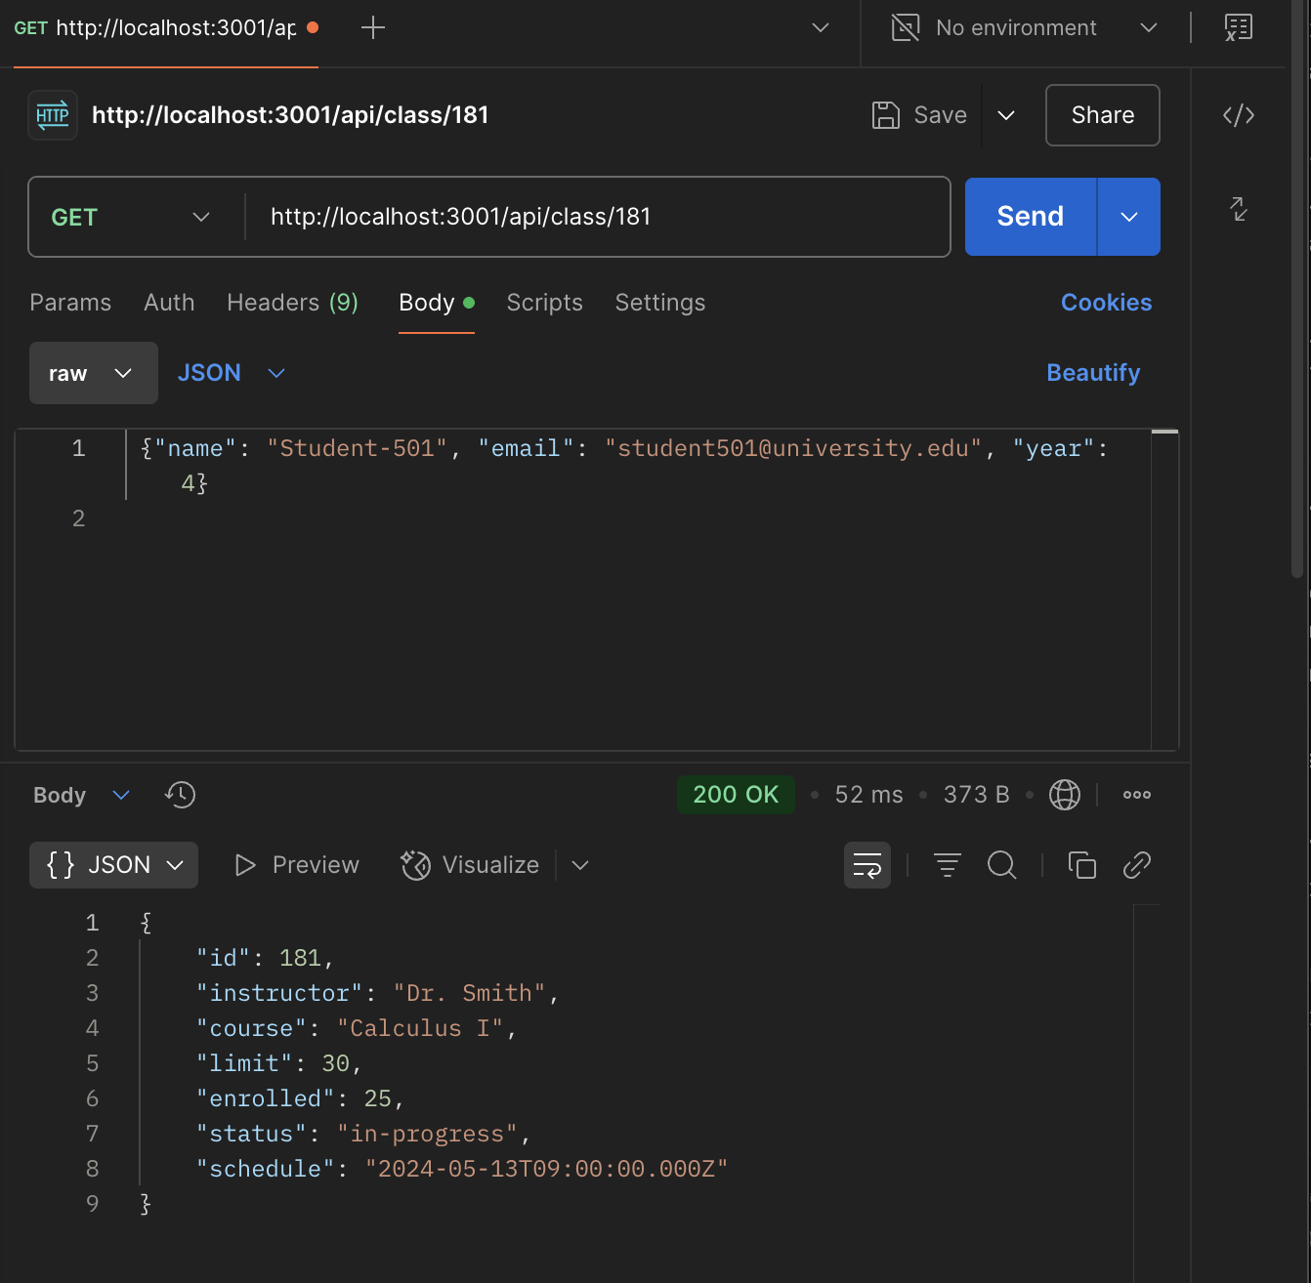

- PUT app/api/class/[id] – updates a class
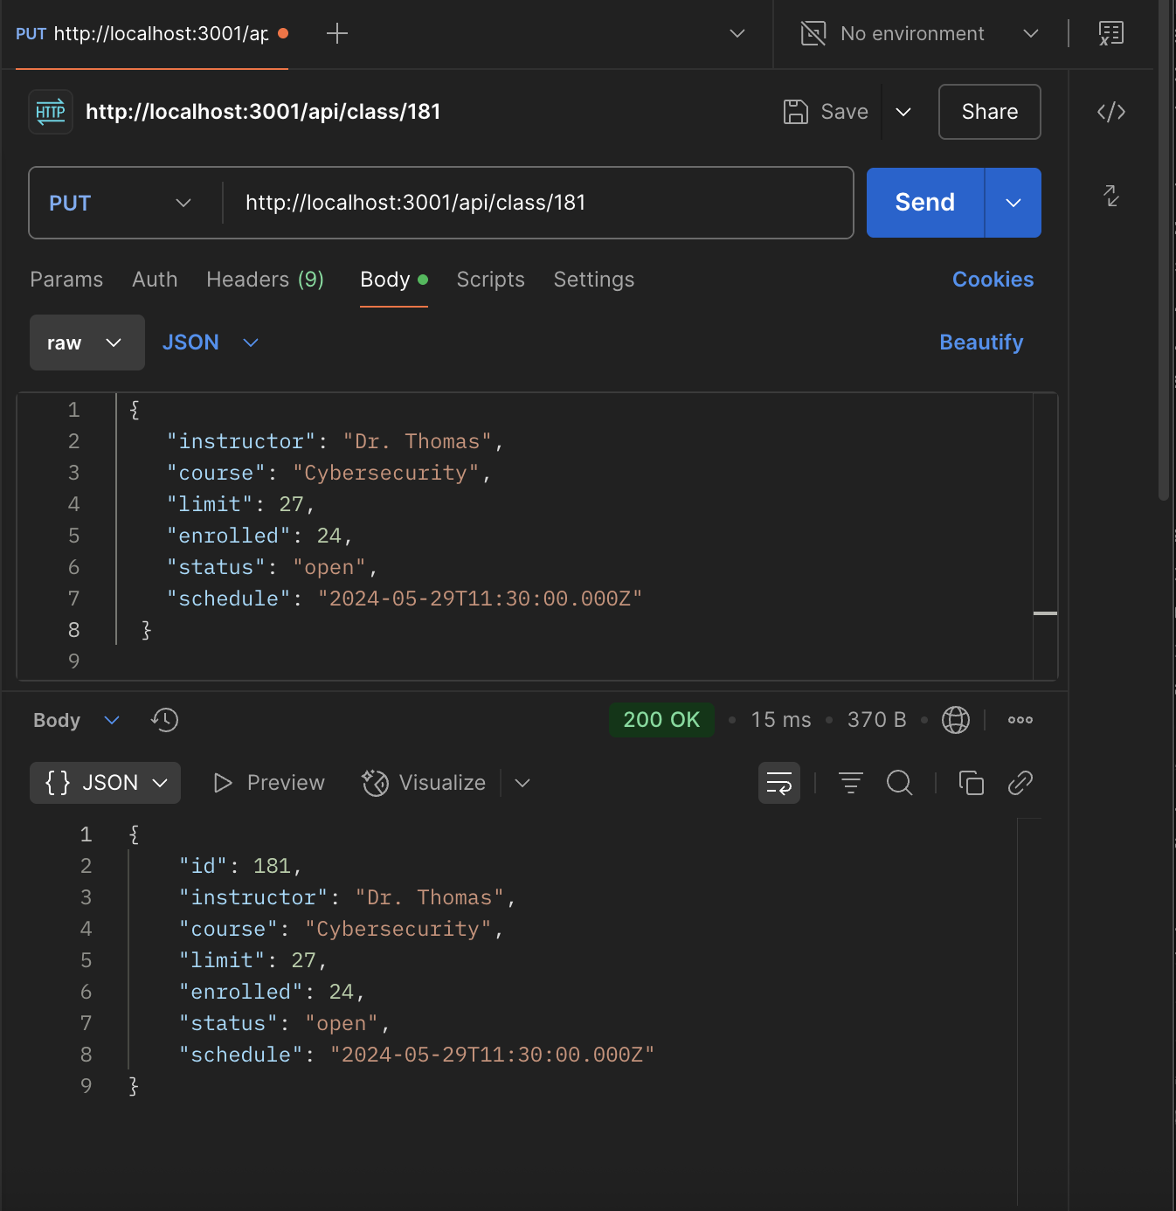

- GET app/api/course/[id] – gets a course
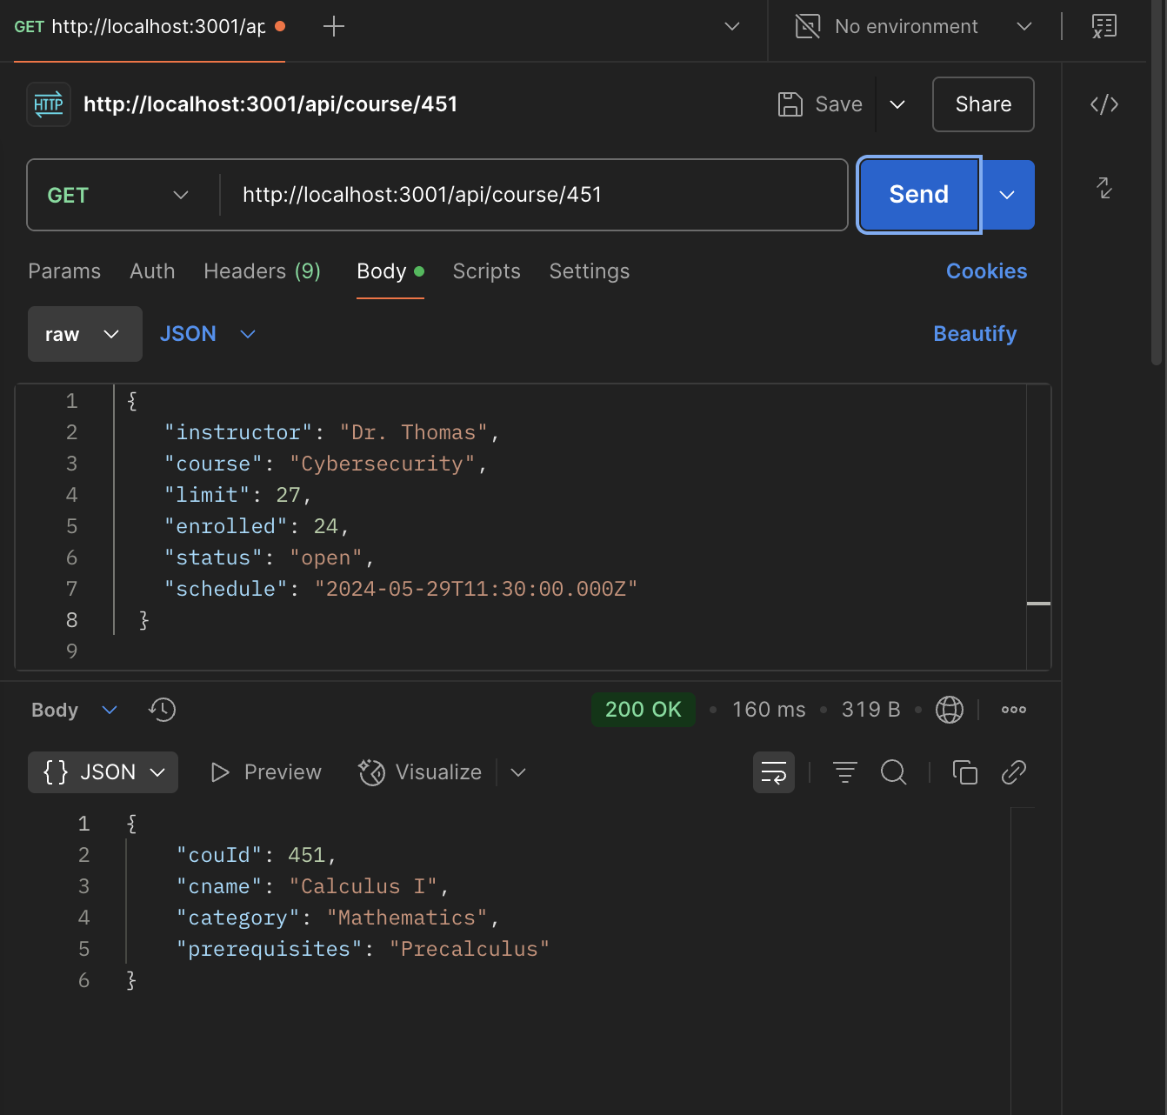

- PUT app/api/course/[id] – updates a course
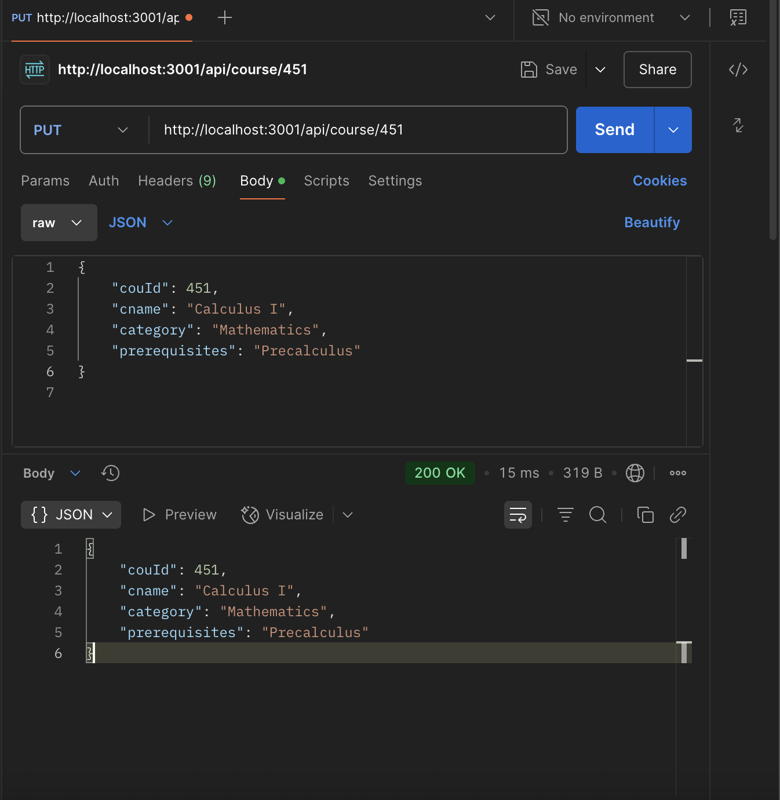

Implemented queries
- return await prisma.student.findMany();
- return await prisma.instructor.findMany();
- return await prisma.course.findMany();
- return await prisma.class.findMany();
- return await prisma.student.findUnique({
- where: { studentId: parseInt(id) },
- return await prisma.instructor.findUnique({
- where: { insId: parseInt(id) },
- return await prisma.course.findUnique({
- where: { couId: parseInt(id) },
- return await prisma.class.findUnique({
- where: { id: parseInt(id) },
- return await prisma.student.create({ data: studentData });
- return await prisma.instructor.create({ data: instructorData });
- return await prisma.course.create({ data: courseData });
- return await prisma.class.create({ data: classData });
- return await prisma.student.findMany({
- where: { year: parseInt(year) },
- });
- }
- return await prisma.student.update({
- data: updatedData,
- where: { studentId: parseInt(id) },
- return await prisma.instructor.update({
- data: updatedData,
- where: { insId: parseInt(id) },
- return await prisma.course.update({
- data: updatedData,
- where: { couId: parseInt(id) },
- return await prisma.class.update({
- data: updatedData,
- where: { id: parseInt(id) },
- return await prisma.student.delete({
- where: { studentId: parseInt(id) },
- return await prisma.instructor.delete({
- //api/instructor/[id]
- where: { insId: parseInt(id) },
- });
- }
- return await prisma.class.findMany({
- //api/open
- where: { status: "open" },
- });
- }
- return await prisma.course.findMany({
- where: { category },
- });
- }

Discussion of the project contribution of each team member

Student name | Student contributions
Nagham Alajmi | Completed 1. Data Model, 2. Prisma, 3. Implemented Seed.js to test the prisma studio, 4. Worked on the data repo, 5. Worked on the web API’s
Lama Aldosari | Completed: worked on Prisma and SQLite, and fully implemented Statistics Dashboard using Next.JS and React, created and tested custom Prisma queries for 10+ statistics, developed and tested seed.js with 500 students and realistic data, designed UI for dashboard with charts and tab navigation
Shaikha AlAli | Completed the server action using Next.js. These actions serve as an interface between the frontend and the backend, enabling seamless communication with data repository

